Winchester District UK Shared Prosperity Fund
Guidance 2025-26

This guidance note provides details for applicants interested in apply for funding under the one year extension to the Winchester District UK Shared Prosperity Fund.

Contents:

About the UK Shared Prosperity Fund
Initial Information
Investment priorities, themes and sub-themes
Eligibility
Delivery Timeline
Submitting your application
Evaluation and Award Process
Payments
Reporting Requirements
Publicity
Procurement Guidelines

About the UK Shared Prosperity Fund

The UK Shared Prosperity Fund was launched in 2022 and covered a three-year funding period ending in March 2025. Its primary goal was to build pride in place and increase life chances across the UK.
For 2025/2026, the government has released a further £900 million of funding for local investment, with Winchester’s allocation amounting to £327,000. After deducting administrative costs we have an available fund of £310,000 which can be used for capital or revenue spend.
The three priority areas for investment remain the same: communities and place; supporting local business; and people and skills.
The fund retains the original core objectives and themes but in a simplified form. There are now five UK-wide themes and twelve sub-themes focused explicitly on delivering the government’s Key Missions. The fund’s five themes are:
- Healthy, Safe and Inclusive Communities
- Thriving Places
- Support for Business
- Employability
- Skills
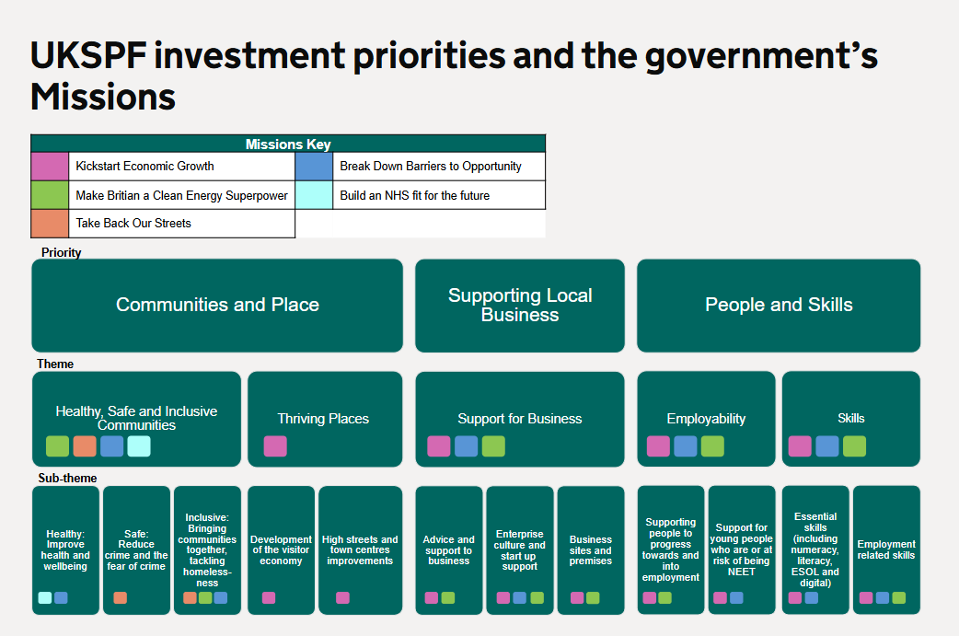

Initial Information

We particularly welcome applications for grant awards in the £25,000 to £50,000 range but we are open to requests for smaller or larger sums and encourage you to contact prosperity@winchester.gov.uk for a preliminary discussion, regardless of the size of your project.

Opening Date: Thursday 10 April 2025, 9am
Closing Date: Tuesday 27 May 2025, 9am
Applicants Notified: July 2025
All grant funding to be spent by: 28 February 2026

- Any enquiries regarding the fund or submission of an application should be directed to prosperity@winchester.gov.uk
- This is a competitive fund for applications and applications will be assessed against the published evaluation criteria.
- Only one application can be made per organisation, per year.
- We will prioritise applications from businesses and organisations that have not been funded under previous rounds of this funding programme.

Investment priorities, themes and sub-themes
We are looking for businesses and not-for-profit organisations, working on projects that meet at least one of the following themes. We have indicated the amount of funding nominally allocated for each theme, but reserve the right to adjust this based on the demand from project applications.
COMMUNITIES AND PLACE – £180,000 minimum pot (circa 60% of available fund)
In this theme, we particularly welcome projects that tackle isolation, build community cohesion and support those most in need as well as those that improve our high streets and support the development of the visitor economy.
Healthy, Safe and Inclusive communities
Examples could involve schemes or facilities that:
- Improve and broaden the use of community centres, village halls and other buildings that advance community cohesion, especially where they introduce energy efficient measures.
- Improve health and wellbeing through increased participation in physical activities
- Increase access to green and open spaces
- Improve community safety
- Involve local food production and healthy nutrition initiatives.

Thriving places

Projects are invited that:
- Encourage visitors to the district, especially if they are using sustainable transport.
- Increase the accessibility of attractions so a wider range of people can visit
- Activities and facilities that keep our town centres lively and attractive.
- Revitalise our street markets and support local festivals
- Promote and develop our unique cultural, heritage and natural environment assets across the district

SUPPORTING LOCAL BUSINESS – £65,000 pot (circa 20% of available fund)

Through this theme, the government aims to help kickstart the economy, make Britain a clean energy superpower and break down barriers to opportunity. We are looking for projects that help your business to grow by becoming more productive, sustainable and/or digital.

Examples could involve initiatives that:
- Provide business advice and support activities, workshops etc. that target a specific productivity, resource or opportunity issue
- Improve business premises through energy efficiency/generation and or digital connectivity.
- Support land-based businesses and/or farmers to diversify or to increase productivity e.g. sustainable food production schemes
- Support and grow creative businesses, entrepreneurs and freelancers

PEOPLE AND SKILLS - £65,000 pot (circa 20% of available fund)

Under this theme we will be prioritising projects that provide our residents with the skills that our local businesses are struggling to find. These include construction-related skills such as bricklaying, carpentry and retrofit, creative and cultural sector related skills in arts, IT and digital and the visitor economy and the food and drink sector.

Examples could include projects that:
- Combine the research capabilities of higher education institutions with the practical experience of local businesses to develop skills
- Increase residents or employees digital skills
- Increase green / low carbon skills

For more information see the Local Skills Improvement Plan: EM3 (including all of Surrey) LSIP Progress Report - 2024 - Surrey Chambers

Projects can span more than one of the themes or sub-themes outlined above – for example: developing the visitor economy through business support.

Eligibility - Who can apply

Individuals may not apply unless they are sole traders and can demonstrate that they run a business or plan to. We may ask for a business plan that demonstrates market demand.

Any organisation with legal status can receive funding. This may include:
- local authorities / Parish Councils,
- public sector organisations,
- higher and further education institutions,
- private sector companies,
- registered charities and community interest companies limited by guarantee

Organisations based outside the Winchester district can apply but all project activity, beneficiaries and outcomes must be within the district.

Businesses are required to match fund their project following the scheme outlined in the table below:
Size of business | Description/criteria | Amount of match funding required *
Sole trader/freelancer  Social enterprise  Community interest company | A self-employed person who owns and runs their own business as an individual.  A business with specific social objectives among its primary purpose  A special type of limited company that exists to benefit the community rather than private shareholders | None
 | Under the Companies Act 2006 a business must satisfy two or more of the following requirements:
Micro business | Turnover: not more than £632,000  Balance sheet total: not more than £316,000  Number of employees: a headcount of staff of not more than 10 | 10%
Small business | Turnover: not more than £10.2 million  Balance sheet total: not more than £5.1million  Number of employees: a headcount of staff of less than 50 | 25%
Medium business | Turnover: not more than £36 million  Balance sheet total: not more than £18 million  Number of employees: a headcount of staff of less than 250 | 50%

* We will accept revenue as a match funding contribution

What we are unable to fund:

We are unable to fund:
- projects that are or could be supported by Defra funding including:
- The Farming in Protected Landscapes Programme
- The Farming Investment Fund
- The Platinum Jubilee Village Hall Improvement Grant Fund

- The following:

Organisations | - Organisations whose main objective is to raise funds for other charitable organisations  - Political organisations
Activities | - Local or national appeals and fundraising activities  - Activities which are of a wholly and exclusively political or religious nature, or organisations supporting political activism  - Paid for lobbying, entertaining, petitioning or challenging decisions, which means using the Fund to lobby (via an external firm or in-house staff) in order to undertake activities intended to influence or attempt to influence Parliament, government or political activity including the receipt of UKSPF funding; or attempting to influence legislative or regulatory action  - Payments for activities of a party political or exclusively religious nature  - VAT reclaimable from HMRC  - Gifts, or payments for gifts or donations  - Statutory fines, criminal fines or penalties  - Payments for works or activities which the lead local authority, project deliverer, end beneficiary, or any member of their partnership has a statutory duty to undertake, or that are fully funded by other sources  - Contingencies and contingent liabilities  - Dividends  - Bad debts, costs resulting from the deferral of payments to creditors, or winding up a company  - Expenses in respect of litigation, unfair dismissal or other compensation  - Costs incurred by individuals in setting up and contributing towards private pension schemes

Subsidy Control
You are required to consider the UK Subsidy Control Scheme as part of your application. UK subsidy control regime - GOV.UK (www.gov.uk)

Financial Sustainability

Applicants must be able to demonstrate the financial sustainability of their organisation. The council has the right to withdraw any offer of grant aid if, on scrutiny, it becomes apparent that the organisation is not sustainable.
To this end the council will undertake financial due diligence by carrying out a Dunn & Bradstreet check on the organisation making the application.

Planning permissions and licences

If your project involves the development of land or buildings, including the refurbishment of premises, it is likely that it may require permission. If you are unsure whether elements of your project may need approval, please check here

The process of applying for planning consent can be lengthy and might affect your ability to complete your project by the end of March 2026. If your project requires planning consent, please do not apply for any grant under the UK Shared Prosperity Fund until consent is granted.

Policies and Insurances

Organisations should have the relevant policies and permissions in place in order to operate, deliver projects and or provide their service. Where relevant, these may include:
  - Adequate Third Party Public Liability and Employers’ Liability Insurance.
  - Data Protection Policy
  - Conflict of Interest Policy
  - Antislavery Policy
  - Anti-fraud Policy
  - Environmental Policy
  - Equality and Diversity Policy
  - Health and Safety Policy
  - Volunteer Policy
  - Safeguarding Policy

If you have these policies, please upload them with your application. If you do not have one of these policies in place, we ask you to explain why, or a date by which you commit to introducing the policy.
Organisations working with children, young people or vulnerable adults must have a robust protection policy in place and ensure that all active staff and volunteers have undertaken a DBS check.

Delivery Timeline

Activity can start once a signed funding agreement is in place; we anticipate that this is likely to be July 2025. We cannot retrospectively fund work that has taken place. All financial project activity must end by 28 February 2026. We reserve the right to amend this date if for example the government makes changes to the UKSPF programme.

Submitting your application

Applications should be made via the official application form and submitted by the agreed deadline found on our website.

We use an online system called Flexigrant to manage the grant application process. You will need to register with Flexigrant if you have not made a previous application with Winchester City Council. Guidance is available alongside the questions, but if you require any additional support please contact prosperity@winchester.gov.uk.

Evaluation and Grant Award Process

Grants (investment funding) process for project investments

Proposal Invited

- Project £24,999 – Simplified business case application
- Projects £25,000+ Detailed business case application

Grant (investment funding) eligibility and award criteria

This is a competitive fund and each application will be assessed and scored against the grant eligibility and criteria by a panel of Officers.

At the time the application is submitted, to enable the council to assess applications fully, all sections must be completed with all the information you wish considered together with all the documents requested. There will not be a further opportunity to provide additional details.

There are a number of pass or fail questions in the application form. If any of these are scored as a fail, the application will not be considered any further. In addition to these the application will be tested against the criteria outlined below and considered either acceptable or unacceptable. In the instance that the assessment is deemed unacceptable the application will not be considered any further.

All applicants will be advised of the outcome in writing. The council’s decisions with regards to funding are discretionary and no appeals process is available.

Successful applicants will be required to sign a grant funding agreement with Winchester City Council. An example of the grant agreement is published on our website.

Applicants must be ready to start delivery immediately after signing the funding agreement.
All applications will be assessed and evaluated using a consistent approach and scored against the criteria set out below:

Assessment Area | Responses to the following questions will be considered | Scoring weighting
Achievement of fund priorities, outputs and outcomes | 4.1 Project Details  4.2 Project Impacts  - Beneficiaries  - Equality & diversity  - Sustainability  4.3 Outputs and Outcomes | 50%
Deliverability | 4.4 Project Delivery  - Dates & milestones  - Experience & capacity  - Risks | 20%
Monitoring and Evaluation | 4.5 Monitoring & Evaluation | 10%
Funding | 5.1 Project costs  5.1 Finance Plan  - Value for money & affordability | 20%

Score | Each assessment area will be scored in accordance with the following scoring model.
5 – Excellent | The response exceeds the required standard, answers the area of assessment with precision and relevance, and adds value and innovation as appropriate. Exceptional demonstration by the applicant of the relevant ability, understanding, skills, and quality measures required to provide meet the requirements of the fund. Strong evidence to support the proposal is provided, where appropriate.
4 – Good | The response meets the required standard, answers the areas of assessment fully and with relevance. Good demonstration by the applicant of the relevant ability, understanding, skills, and quality measures required to meet the requirements of the fund. Good evidence to support the proposal, where appropriate.
3 – Satisfactory | The response meets the minimum required standard in an acceptable level of detail. Satisfactory demonstration by the applicant of the relevant ability, understanding, skills and quality measures required to meet the requirements of the fund. Standard or generic evidence is provided to support the proposal, where appropriate.
2 – Minor Reservations | The response partially meets the minimum required standard and relevance but with some detail missing or not answered. Contains minor shortcomings in the demonstration by the applicant of the relevant ability, understanding, skills and quality measures required to deliver the requirements of the fund. Limited evidence is provided to support the response, where appropriate.
1 – Serious Reservations | The response fails to meet the minimum required standard. Inadequate detail is provided, which is not relevant to the requirements of the area of assessment or there are significant omissions meaning there are considerable reservations of the applicant’s relevant ability, understanding, skills, and quality measures required to meet the requirements of the fund. Little or no evidence to support the response is provided and raises many concerns.
0 – no score – Fail | Applications that ‘Fail’ will not be considered further  No response or information is provided to allow proper evaluation, ability is not evidenced.

The council reserves the right to reject the application entirely if it receives scores of ‘2 - minor reservations” or ‘1’ – serious reservations’.

Payments
The grant will be paid to you in arrears upon receipt of proof of defrayal (payments), an updated output and outcome report, and a project narrative. This will all be managed through the same online system that manages your application. Claims can be made as soon as eligible expenditure is incurred, with a maximum of three staged payments.

Reporting Requirements
Applicants must ensure that governance is in place to achieve the reporting requirements of the fund, including expenditure, outputs and outcomes. Applicants will be expected to submit reports when they make claims. Indicative (flexible) dates for these are as follows:
15 August 2025
15 November 2025
15 February 2026
15 March 2026 (End of Project Report)

Publicity

Applicants must adhere to the published branding and marketing requirements of UK Shared Prosperity Fund which will be included in contract information.

Procurement

All grant spend must follow the below Procurement guidance. Any costs not following this guidance will not be permitted.
Minimum procedure | Minimum procedure
Obtain single verbal or written quotation, or use suitable framework agreement | £0 - £2,499 | Direct award
Determine the evaluation criteria and model  Invite a minimum of three written quotations | £2,500 - £24,999 | 3 written quotations or prices sought from relevant suppliers of goods, works and / or services
Formal competitive tenders have been invited either:  • by Public Invitation to Tender (Open Tender) | Over £25,000 | Formal tender process

