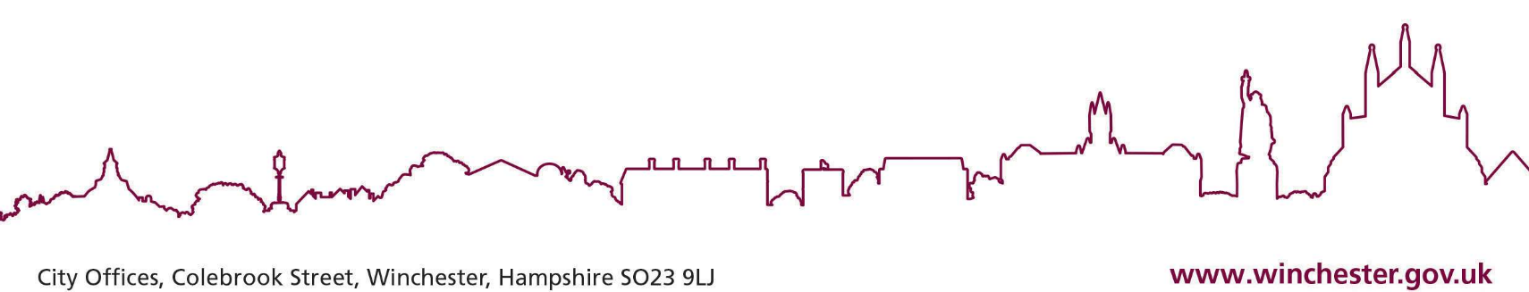
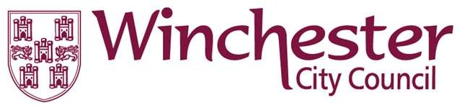
1 The English Indices of Deprivation 2019 (publishing.service.gov.uk)
2 Welsh Index of Multiple Deprivation (full Index update with ranks): 2019 | GOV.WALES
3 Scottish Index of Multiple Deprivation 2020 - gov.scot (www.gov.scot)

Statement of Intent for ECO4

Winchester City Council ECO4 Flexible Eligibility Statement of Intent Local Authority name: Winchester City Council
Publication Date: 17th May 2022
Version number: V.1.2
Publication on web site: www.Winchester.gov.uk

This statement sets out Winchester City Council’s flexible eligibility criteria for the Energy Company Obligation (ECO4) scheme from April 2022 – March 2026.

The ECO4 scheme will focus on supporting low income and vulnerable households. The scheme will improve the least energy efficient homes helping to meet the Government’s fuel poverty and net zero commitments.

The flexible approach for Local Authorities (LAs) to identifying fuel poor and vulnerable households who may benefit from heating and energy saving measures is referred to as “ECO4 Flex”.

The Council welcomes the introduction of the ECO4 Flex eligibility routes as it helps the Council achieve its plans to improve the homes of those in fuel poverty or vulnerable to the cold.

The Council is publishing this Statement of Intent (SoI), on the 17th May 2023 to confirm that each of the households declared will adhere to at least one of the four available routes outlined below:

Route 1: SAP bands D - G owner-occupied households (or E-G for privately rented households) with a gross household combined income of £31,000 or less. This cap applies irrespective of the property size, composition, or region.

Route 2: SAP bands E- G owner-occupied households (or E-G for privately rented households) that meet a combination of at least two of the following proxies:

Proxy 1) Homes in England in Lower-layer Super Output Area 1-3 (LSOA), or homes in Welsh provision LSOA 1-3 on the Welsh Index of Multiple Deprivation 2019, or the Index of Multiple Deprivation for 2020, published by the Scottish Government
Proxy 2) Householders receiving a Council Tax reduction (rebates based on low income only, excludes single person rebates).
Proxy 3) Householders vulnerable to living in a cold home as identified in the National Institute for Health and Care Excellence (NICE) Guidance. Only one from the list can be used, excludes the proxy ‘low income’.
Proxy 4) A householder receiving free school meals due to low-income.
Proxy 5) A householder supported by a LA run scheme, that has been named and
described by the LA as supporting low income and vulnerable households for the
purposes of NICE Guideline. This includes those referred to the Household Support
Fund (administered by CA and contacted via 0808 278 7861 or advice@cawinchesterdistrict.org.uk), in receipt of assistance from the Hitting the Cold Spots Service (run by the Environment Centre (tEC) on behalf of Hampshire County Council ) or in receipt of assistance from Winchester City Council services for fuel poverty, for example through direct referral by the council’s Financial Inclusion Officer.
Proxy 6) A household referred to the LA for support by their energy supplier or CA or CA Scotland, because they have been identified as struggling to pay their electricity and gas bills.

* Note proxies 1 and 3 cannot be used together.

Route 3: SAP bands D- G owner-occupied (or E-G for privately rented households) that have been identified by their doctor or GP as low-income and vulnerable, with an occupant whose health conditions may be impacted further by living in a cold home. These health conditions may be cardiovascular, respiratory, immunosuppressed, or limited mobility related.

This is because the Council has identified a positive correlation between households who suffer from long-term health conditions and living off a low-income, with living in poorly insulated homes.

Route 4: SAP bands D- G owner-occupied households (or E-G for privately rented households) that are referred under Route 4: Bespoke Targeting. Suppliers and LAs can submit an application to BEIS where they have identified a low income and vulnerable household, who are not already eligible under the exiting routes.

Declaration and evidence check confirmation.
All potentially eligible households should apply through the following ways to ensure that they can either benefit from the scheme or be assessed for eligibility under any other relevant programme:
- Via local installers own marketing processes
- Self-referrals from residents
- Frontline council offices
- From established links with CAB, Age UK and Hampshire’s Hitting the Cold Spots
- Health and Social Care professionals
The officer(s) below will be responsible for checking and verifying declarations and associated evidence submitted on behalf of the local authority:

Position | Named individual | Responsibilities
LA Contacts | Anna Wyse – Sustainability Officer awyse@winchester.gov.uk | Signing LA declarations. Auditing applications.
LA Contacts | Kevin Reed– Senior Private Sector Housing Officer  KReed@winchester.gov.uk | Signing LA declarations. Auditing applications.
NEF Contact | Matt Neal suppliernetwork@nef.org.uk | Management of ECO Flex application process and NEF Approved Supplier Network.

Any supplier or installer who seeks a council declaration on behalf of an eligible resident will first need to be registered with the ‘NEF Supplier Network’. The Network ensures that councils have information about the standards, practices and accreditations of installers working in their area reducing the risk of fraud, poor quality installations and the exploitation of vulnerable residents that the council is looking to assist via ECO Flexible Eligibility. For further information about the Network and guidance on how to register, suppliers should contact suppliernetwork@nef.org.uk

CEO or dedicated responsible person mandatory signature
Winchester City Council will administer the scheme according to BEIS’ ECO4 Order and will identify eligible households via Ofgem’s application process. The CEO of the Council will oversee the process of identifying eligible households under ECO4 Flex. The eligibility information will be stored securely in line with the Council’s data protection policy, Information Commissioner’s Office Data Sharing Code, and BEIS guidance.

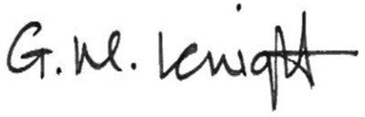
Signature:

Name: Gillian Knight

Job Title: Corporate Head of Housing

Date of signature: 17th May 2023

For any general enquires relating to this SoI, please contact awyse@winchester.gov.uk.

The English Indices of Deprivation 2019 (publishing.service.gov.uk)
Welsh Index of Multiple Deprivation (full Index update with ranks): 2019 | GOV.WALES
Scottish Index of Multiple Deprivation 2020 - gov.scot (www.gov.scot)

