**WINCHESTER DISTRICT TEN YEAR**

**GREEN ECONOMIC DEVELOPMENT STRATEGY:**

**DRAFT ACTION PLAN 2022 - 2024**



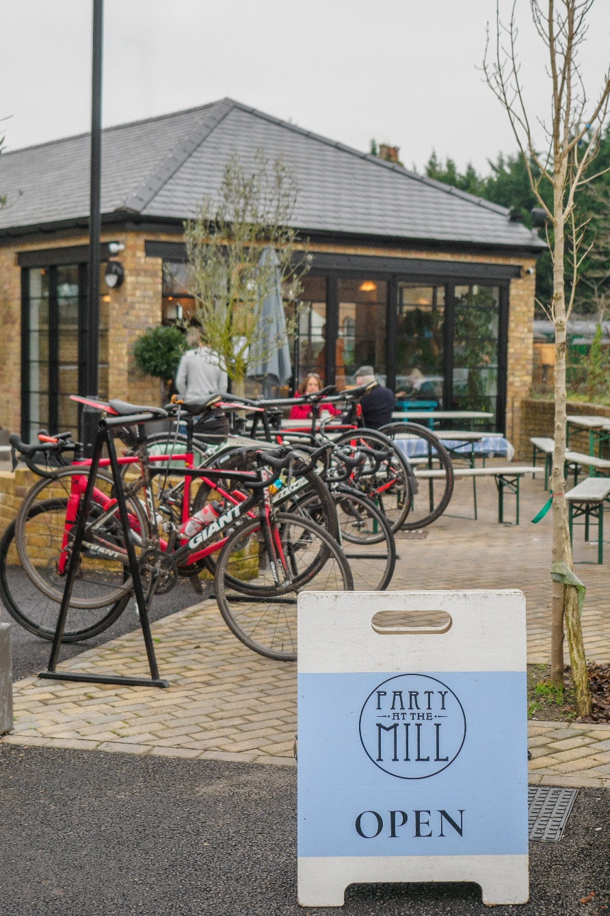

Contents

page

1. Introduction…………………….. 3
2. Purpose of the plan……………. 4
3. Links to the council plan………. 5
4. Issues and evidence…………… 7
5. Monitoring and evaluation……. 9
6. Governance…………………….. 9
7. Routes to delivery…..………….. 12
8. Prioritisation……………………… 12
9. Phase 1 Action Plan…………… 16
10. Implementation Framework…. 21
11. Implementation Plans…….. 23
12. **Introduction – The Green Economic Development Strategy 2022-2032**

Work commenced in March 2021 to create a new economic strategy for Winchester district. Consultant Urban Foresight and Third Life Economics were appointed and in October 2021 the council approved a Green Economic Development Strategy (GEDS) that consists of:

* Evidence base
* A framework strategy of thirty-four actions, grouped under six policy themes to achieve eight outcomes which could be evaluated through the lenses of four scenarios

*(add diagram)*

This action plan forms part of the next steps for the delivery of GEDS.

Why now?

The previous Economic Development Strategy had expired and therefore a replacement was required. Moreover, Winchester district faces similar global and national challenges to many parts of the country; climate change and decarbonisation, post-COVID recovery, digitalisation, and growing inequalities in a rapidly aging society. The GEDS outlines how these can be addressed and make the most of the opportunities for green growth in a way that is distinctive to Winchester district. It also reflects how government policy and funding is responding to these societal challenges.

The next ten years will see national government policy driving local authorities and local economies closer to net zero carbon emissions. This transition will be underpinned by public and private investment in new infrastructure, innovation, growth of new goods and services, and demand for new jobs and skills.

Winchester district has unique strengths and assets which provide a platform to accelerate economic development well positioned to capitalise on significant green growth opportunities. Economic growth and the transition to net zero carbon is becoming a single joined-up policy priority across the UK.

The GEDS aims to make sure Winchester district benefits from the new jobs, goods, and services that the whole of the UK will need in the next decade. As a next generation strategy the GEDS is also designed to deliver well-being, reduce inequalities, develop resilience, and enable the transition to a more sustainable economy.

1. **Purpose of the plan**

This action plan will focus on activity over the two year period 2022 to 2024. It considers the actions that have been outlined in GEDS, grouped in the six policy themes which lead to the following outcomes:

* Increased business density and diversity
* Higher skills and productivity
* Reduced socio-economic and spatial inequality
* More affordable, sustainable, and flexible housing stock
* Net CO2 emissions reduced to zero
* Greener transport and less congestion
* More local renewable energy
* Increased biodiversity and green infrastructure

See Appendices Section 8 for an overview of each action and the resulting outcome.

Reflective of the GEDS itself, this plan is an agile, flexible and adaptable plan, focussing on activity over the next two years. As such, it should not be regarded as final as it will recognise opportunities as they arise that could enable actions, not currently considered in this first period of activity, to be bought forward for consideration. The plan will be used as a key tool to address the issues and challenges illustrated in the strategy and which are outlined in section four. The monitoring and evaluation process, outlined in section five, enables this approach.

A number of framework implementation plans are contained within this version of the action plan, and development of other implementation plans, along with the mobilisation of the steering group and/or dedicated action groups, will be used to take forward agreed actions over the next two year.

Whilst this is a council led plan, it has and will continue to be developed and delivered in partnership with key stakeholders across the district. The steering group and the business advisory panel are likely to have more input to provide on this action plan and this will be reflected in future versions.

It is recognised that the actions outlined section nine are at different stages in their development. As such some actions will be

* Completed - in their entirety and benefits accruing from the outcomes will be achieved by 2024,
* Commenced – longer term projects that will not be completed until post 2024 but need to start within the plan period
* Concept - where exploratory and research activity, along with influencing policy and planning, will form the bulk of the work by 2024.

It is recognised that a number of these actions form part of longer term strategies being addressed elsewhere, in the council or by one of our partners or stakeholders.

1. **Links to the Council Plan**

The Council has developed its plan to 2025 which sets out what it wants to achieve and to address the main challenges facing the Winchester district. “Vibrant local economy” and “Tackling the Climate Emergency and creating a greener district” form two of the five priorities of the plan and align directly to the ambitions outlined in the Green Economic Development Strategy. In addition to these two priorities, actions outlined in the GEDS will also assist in tackling priorities including “Living Well” and “Homes for All”.

|  |  |
| --- | --- |
| Tackling the Climate Emergency | * Deliver urban heat mitigation measures |
| Vibrant local economy | * Collaborate to extend the EM3LEP digital spine * Co-ordinate innovation and knowledge-sharing in the rural and land-based economy * Collaborate with rural land-based businesses and the South Downs National Park Authority to increase biodiversity * Deliver a Sustainable Tourism strategy * Collaborate with the district’s educational institutions to grow opportunities for the creative and cultural sector |
| Homes for All  Living Well | * Deliver a significant retrofit campaign * Encourage increased housing supply |

In addition to the Council Plan, the actions outlined in the Green Economic Development Strategy directly align to and will support the delivery of, the following council strategies and major programmes:-

* 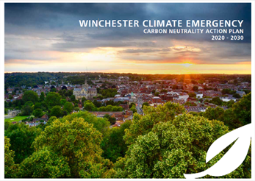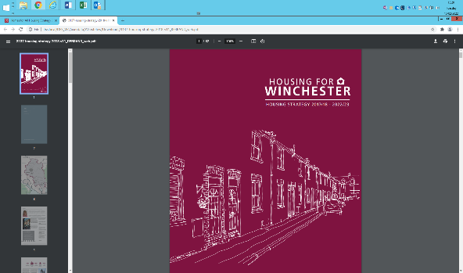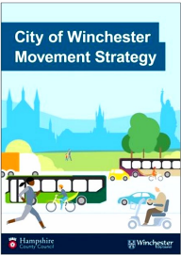The Carbon Neutrality Action Plan
* The City of Winchester Movement Strategy
* The New Homes Programme
* Central Winchester Regeneration

Furthermore it is aligned to, and is in support of, Hampshire 2050 and the work being carried out on behalf of Hampshire County Council by the New Economic Foundation, as well as key priorities outlined in strategies developed by the South Downs National Park Authority.

1. **Issues and evidence**

There are a range of issues and challenges outlined in the GEDS which have been considered when developing the action plan. The table below outlines some of the key global, national and local issues to be considered.

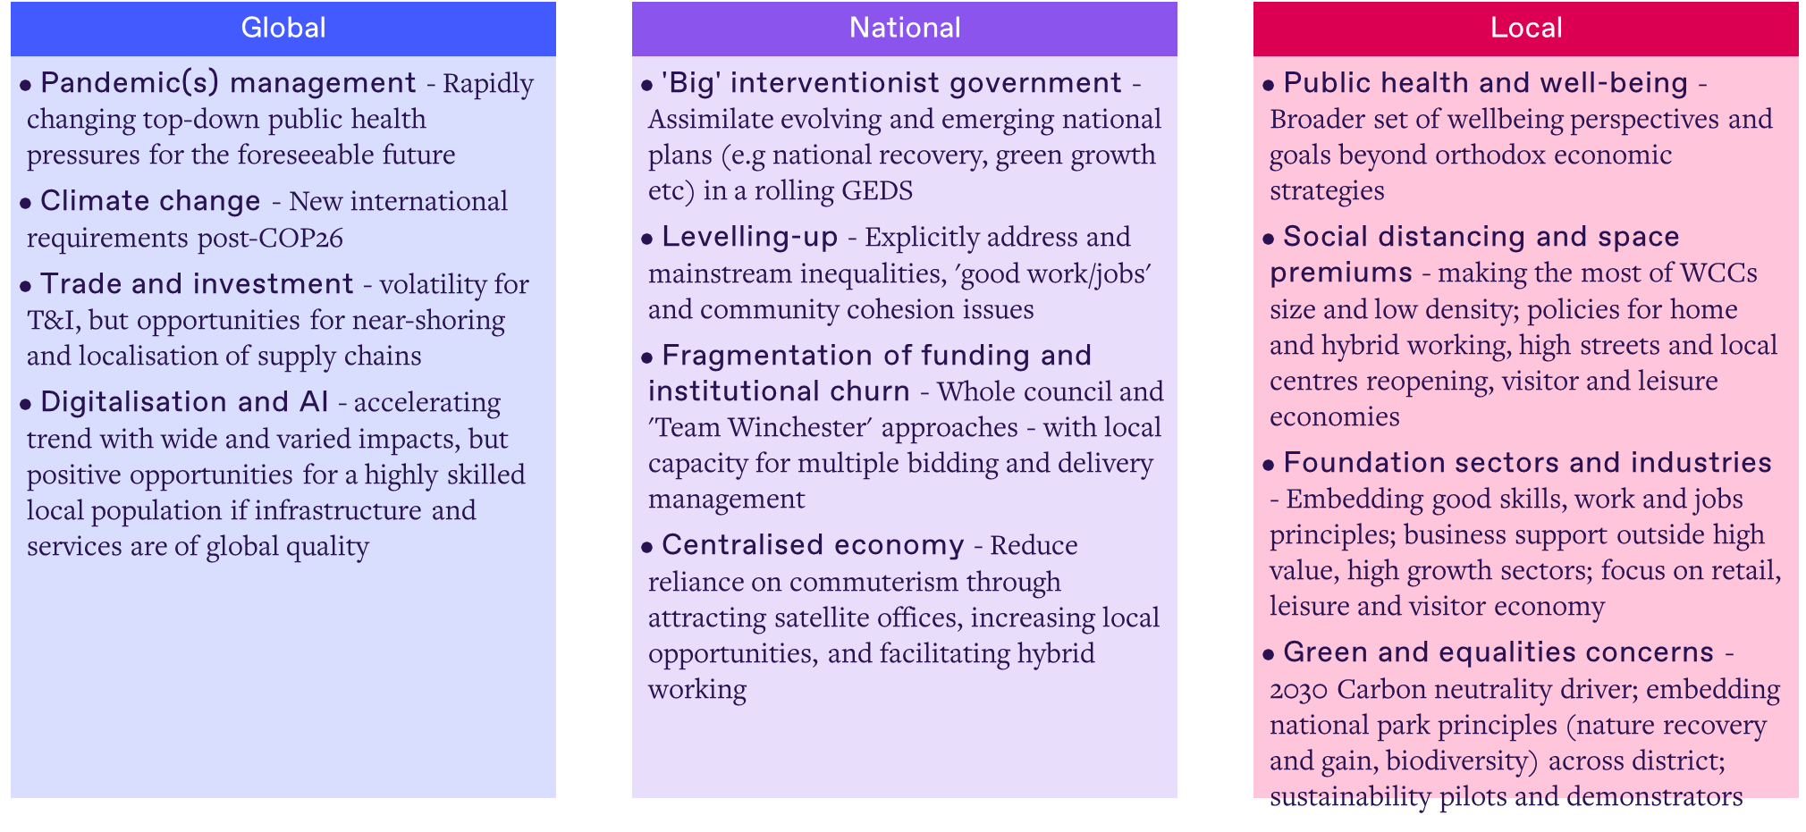

More specifically when considering Winchester district directly, the table overleaf outlines the strengths and weaknesses along with the opportunities and threats which face the district now and into the foreseeable future. The actions, as part of this initial two year plan, along with the main suite of actions to be delivered by 2031, aim to recognise and act on the strengths, capitalise on the opportunities, minimise the weaknesses and address the threats.

|  |  |
| --- | --- |
| **STRENGTHS**   * **Relatively affluent, high performing district on many metrics** * **A rich, diverse, distinctive geography, economy, and culture** * **Considerable business vitality, high level skills, and important anchor institutions with public/social/environmental purposes** * **Well-located between London and Southampton with strong connectivity to both and respective city regions** * **Seemingly not as vulnerable to pandemic, Brexit impacts, and other potential shocks as many places** | **WEAKNESSES**   * **Typical non-metropolitan aging demographic challenges** * **Major housing market pressures and tensions** * **Lack of major business clusters anchored by global players and a well-defined innovation eco-system** * **High per capita CO2 emissions, very reliant on car-based transport within the district** * **Not particularly well-placed to command policy attention and prioritisation from Government and LEPs** |
| **OPPORTUNITIES**   * **A strong stock of underlying assets and capabilities, together with considerable enthusiasm and opportunities for a green recovery, natural capital, and social wellbeing approaches** * **UK Green Recovery, LEP focus on LCEGS, and Hampshire 2050 processes provide opportunities to attract investment and incentivise indigenous development** * **Strengthened anchor institution collaboration (including SDNP) together with diverse SME business vitality could be purposeful and agile if communities can be empowered and buy-in to the GEDS.** | **THREATS**   * **Potential national/regional post-lockdown economy reduces domestic demand and levels of private investment, whilst prescriptive requirements and low resourcing limit local freedoms, flexibilities, and delivery capacity** * **Risks of complacency and resistance to change may inhibit necessary decisive, radical delivery of change** * **Post-COVID trends significantly weaken city and town centres, business, and community vitality, and increase social inequalities and exclusion for some groups** |

1. **Monitoring and Evaluation**

A set of key performance indicators (KPIs) will be agreed for each of the eight outcomes outlined in GEDS to serve as a measure of the green economic benefits that the delivery of GEDS will bring about. An initial set of indicators has been proposed and these will be added to, or changed, as appropriate through the delivery of interventions and actions. See Appendices Section 9.

The progress against KPIs and the delivery of actions will be monitored and reviewed both internally (through exiting performance management processes) and externally through the GEDS governance structure. Throughout the life of the strategy the four scenarios below will also be used as lenses through which to evaluate the prevailing need for action should economic, social and environment policy and needs shift.

• Levelled up district

• 20-minute communities

• Resilient district

• A vibrant place to do business

In the latter part of this two year action plan, a further action plan will be developed for the next period of activity, likely to cover the period of 2024 – 2027.

1. **Governance**

Internal

The council has established a Green Economic Development Strategy Programme Board. Its members will be:

* Cabinet member for Business and Culture
* Cabinet member for Climate Emergency
* Cabinet member for Community & Housing
* Shadow Cabinet member for Economy
* Strategic Director
* Corporate Head of Economy & Community (Project Sponsor)
* Service Lead Economy & Tourism (Programme Lead)
* Service Lead Community & Wellbeing

The GEDS Programme Board’s primary focus is to oversee delivery and provide accountability for the GEDS 2022-2032. Its role will be to:

* Provide guidance / advice on resolutions to issues / delays / constraints that are preventing delivery
* Consider / raise interdependencies with corporate programmes and projects
* Consider resource implications – financial and staffing etc
* Review
  + Programme risks
  + Quarterly progress reports and updates provided by the Implementation Group
  + Annual performance report provided by the Implementation Group

External

The council will continue to host a business advisory panel throughout the life of the GEDS. This public forum will aim to foster collaboration and engage the wider business community in the achievement of the strategy. This will include seeking input on plans for the forthcoming period.

A steering group of key stakeholders and representative organisations has been established and will continue to meet throughout the duration of the two year action plan. The purpose of the steering group will provide a shared focus on achieving GEDS outcomes across the district through a clear, consistent and resources effective approach to the delivery of projects and investments by all those who have a role to play or influencing those that do.

Governance diagram

Key

Council meeting

External / partners

Internal meetings

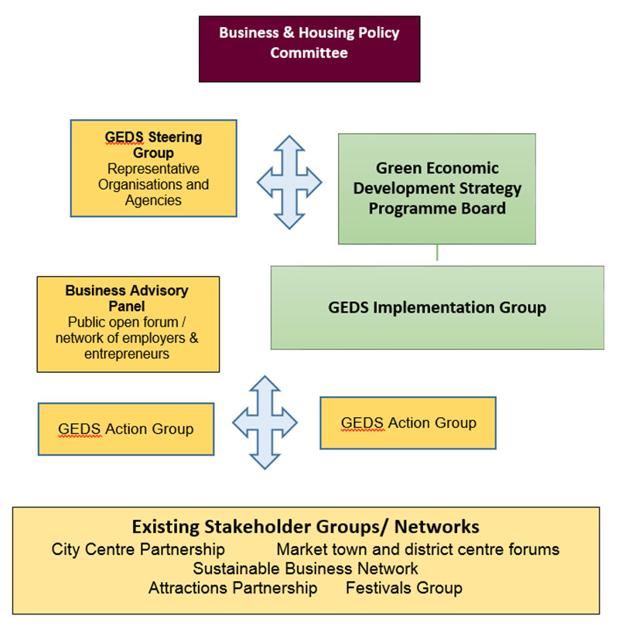

1. **Routes to delivery**

The GEDS has been developed collaboratively across the district’s business community. This collaboration will continue and intensify as this strategy develops the implementation plans around each action. It is recognised that this action plan will be delivered in collaboration with key stakeholders and representative organisations including EM3 LEP, Hampshire County Council, South Downs National Park Authority, Hampshire Chambers of Commerce, Federation of Small Businesses, Winchester BID, Sustrans, University of Winchester, Winchester School of Art, Sparsholt College, Sustainable Business Network along with the wider business community and other appropriate representative bodies and stakeholders.

**Action groups** will be established where appropriate to support the delivery of this two year plan. Such groups will be facilitated by council officers and made up of officers, businesses, stakeholders and representative organisations who have an interest in and can enable the delivery of the action and its associated implementation plan.

An **implementation group** that comprises of officers across the council who will work together to ensure the action plan and associated Green Economic Development Strategy outcomes are fully embedded in appropriate strategies, policies and work programmes. The group will be responsible for delivery of projects being undertaken by the action groups.

1. **Prioritising the Action Plan**

The GEDS suggested thirty-four actions under six key themes. These actions represent varying degrees of priority and fall into one or more of the following categories:

* Enabling Policy
* Investment/Delivery
* Partnership Working
* Research/Feasibility

A number of actions will move through one or more of the above categories during its life cycle.

Of the initial thirty-four actions put forward in GEDS four have been removed. These were deemed as operational and as such are more appropriately considered in specific existing work programmes rather than in this strategic context. These are as follows:

* IB2: Collaborate to refresh CRM and business relationship management
* IB8: Deliver a post-COVID relocation prospectus
* CCVE3: Co-ordinate rural tourism businesses
* CCVE4: Co-ordinate us of local creative capabilities in non-creative businesses and vice versa

A range of activities have been undertaken in order to establish which actions will be taken forward and which will form part of the first two year action plan. This included and the detail of which are given in the Appendices:

* A series of meetings and exercises undertaken with the Steering Group
* A Business Advisory Panel which included live on-line
* Review sessions with Corporate Heads of Service and associated teams to consider how GEDS priorities align with existing work programme priorities and delivery timelines across the council
* An Impact and Effort analysis
* A co-benefit/co-dependency analysis
* A division of responsibilities overview

By undertaking the above activities and engagement the remaining thirty actions have been prioritised against a timeline of phased delivery, within the following three specific phases:

* Phase 1: 2022 – 2024
* Phase 2: 2024 – 2027
* Phase 3: 2027 – 2032

The Action Plan demonstrates separately those actions which are:

* Green – completed - Will be delivered in their entirety in the action plan period shown
* *??? - Commenced ??*
* Yellow – concept - Are in an exploratory/development phase prior to delivery

Phase 1 will aim to achieve:

|  |  |  |
| --- | --- | --- |
| Stage | Lead | Number |
| **Completed**  Actions completed in their entirety by the end of this phase | 3 = Economy & Tourism Teams | 3 |
| **Commenced**  Actions that are already underway and where delivery will be during and beyond Phase 1 | 2 = Economy Team  1 = Transport Team  2 = Housing Team  1 = Natural Environment & Recreation Team | 6 |
| **Concept**  Actions that will commence exploratory/research/feasibility activity during this phase, but not be delivered until future phases | 6 = Economy Team  3 = Transport Team  3 = Housing Team  1 = Natural Environment & Recreation Team  2 = Sustainability Team | 12 |

The actions being delivered in Phase 1 Action Plan outlined below have been assessed as high impact, as illustrated in the impact effort analysis. The chart below illustrates eight actions receiving intervention in the Phase 1 Action Plan, of which four are high impact but which also require high effort and the remaining four are also high impact but require lower effort.



1. **Phase 1 Action Plan**

**Completed:** Actions delivered in their entirety

|  |  |  |  |  |  |  |  |
| --- | --- | --- | --- | --- | --- | --- | --- |
| **Policy Theme code** | **Policy Theme** | **Action Plan description** | **Implementation Lead** | **Example Action/Implementation Group External stakeholders** | **GEDS Outcome** | **2022/23** | **2023/24** |
| CCVE1 | Culture, creative & visitor economy | **Deliver** a Sustainable Cultural Strategy | Tourism Marketing & Development Team | Hampshire Cultural Trust Play to the Crowd Cultural Network Winchester School of Art University of Winchester Festivals Group | Net CO2 emissions reduced to zero  Increased business density and diversity |  |  |
| CCVE2 | Culture, creative & visitor economy | **Deliver** a Sustainable Tourism Strategy | Tourism Marketing & Development Team | Discover Winchester Attractions Group Visit Hampshire Tourism South East Visit England/Britain Relevant sustainability partners | Net CO2 emissions reduced to zero  Increased business density and diversity |  |  |
| CCVE5 | Culture, creative & visitor economy | **Co-ordinate** the establishment and operation of a creativity-themed business cluster network | Economy & Cultural Development Teams | Hampshire Cultural Trust Play to the Crowd | Increased business and density Higher skills and productivity |  |  |

**Commenced:** Actions where delivery includes and is beyond Phase 1

| **Policy Theme code** | **Policy Theme** | **Action Plan description** | **Implementation Lead** | **Example Action/Implementation Group External stakeholders** | **GEDS Outcome** | **2022/23** | **2023/24** |
| --- | --- | --- | --- | --- | --- | --- | --- |
| IB7 | Innovative Business & Economy | **Encourage** repurposing retail space | Economy Team | Winchester City BID Market Town Representation Landlords & Real Estate Agents | Increased business density & diversity |  |  |
| SFE1 | Skills & competitiveness | **Co-ordinate** development of a low carbon offsite and Sustainable Construction Skills Academy | Economy Team | Hampshire County Council EM3 LEP | Net CO2 emissions reduced to zero Higher Skills and Productivity |  |  |
| T4 | Connected, public & electric transport | **Collaborate** with HE and HCC on the Movement Strategy | Transport Team | Hampshire County Council Highways England | Net CO2 emissions reduced to zero |  |  |
| HC1 | Affordable, low carbon housing | **Encourage** low or zero carbon regeneration site testbed and development | Housing Team |  | Net CO2 emissions reduced to zero |  |  |
| HC2 | Affordable, low carbon housing | **Deliver** a significant retrofit campaign | Housing Team |  | More affordable, sustainable, and flexible housing stock Net CO2 emissions reduced to zero Reduced socio-economic and spatial inequality |  |  |
| GI5 | Green infrastructure, biodiversity & renewable energy | **Deliver** urban heat mitigation measures | NERT Team |  | Increased biodiversity and green infrastructure |  |  |

**Concept:** Actions in exploratory & research stage / first year of delivery

| **Policy Theme code** | **Policy Theme** | **Action Plan description** | **Implementation Lead** | **Example Action/Implementation Group External stakeholders** | **GEDS Outcome** | **2022/23** | **2023/24** |
| --- | --- | --- | --- | --- | --- | --- | --- |
| IB1 | Innovative Business & Economy | **Collaborate** to extend the EM3 LEP digital spine | Economy Team | LEP/HCC | Increased business density & diversity Reduced socio-economic and spatial inequality |  |  |
| IB3 | Innovative Business & Economy | **Co-ordinate** innovation and knowledge-sharing in the rural and land-based economy. | Economy Team |  | Increased business density & diversity |  |  |
| IB4 | Innovative Business & Economy | **Co-ordinate** a digitalcluster programme | Economy Team |  | Net CO2 emissions reduced to zero Increased business density and diversity |  |  |
| IB5 | Innovative Business & Economy | **Co-ordinate** a single business carbon reduction and responsible management programme | Economy Team |  | Net CO2 emissions reduced to zero  More local renewable energy Higher skills and productivity |  |  |
| IB6 | Innovative Business & Economy | **Deliver** flexible, affordable grow on/small SME space | Economy Team |  | Increased business density & diversity Reduced socio-economic and spatial inequality |  |  |
| T1 | Connected, public & electric transport | **Deliver** a plan for the next phase of EV charging infrastructure strategy | Transport & Sustainability Teams |  | Net CO2 emissions reduced to zero Greener Transport & less congestion |  |  |
| T2 | Connected, public & electric transport | **Deliver** new park and ride capacity to the north of the city. | Transport & Major Pojects Teams | In partnership with HCC | Net CO2 emissions reduced to zero Greener transport and less congestion |  |  |
| T3 | Connected, public & electric transport | **Collaborate** with HCC on Bus Improvement Plan |  |  | Net CO2 emissions reduced to zero Greener transport and less congestion |  |  |
| T5 | Connected, public & electric transport | **Co-ordinate** a high profile EV fleet commitment | Transport Team |  | Net CO2 emissions reduced to zero |  |  |
| HC4 | Affordable, low carbon housing | **Encourage** increased housing supply | Housing Team |  | More affordable, sustainable, and flexible housing stock |  |  |
| GI7 | Green infrastructure, biodiversity & renewable energy | **Co-ordinate** green energy initiatives | Sustainability Team |  | More local renewable energy Reduced socio-economic and spatial inequality |  |  |
| GI8 | Green infrastructure, biodiversity & renewable energy | **Co-ordinate** renewable energy and energy efficiency innovation and skills programme |  |  | More local renewable energy |  |  |

**Action for Phases 2 and 3**

The remaining eight actions are prioritised for later phases of the GEDS action plans.



Phase 2 and 3 action plans are outlined in the Appendices Section 7.

As described previously, the action plans which underpin the overall GEDS delivery are agile and as such will adjust in response to factors affecting prioritisation over the life of the strategy. Therefore those actions outlines in phases 2 and 3 should at this stage be regarded as indicative.

1. **Framework Implementation Plans Phase 1**

|  |  |
| --- | --- |
| Stage | **Links to Implementation Plans** |
| **Completed**  Actions completed in their entirety | CCVE1: Deliver a Sustainable Cultural Strategy ***(will web-link to plan)***  CCVE1: Deliver a Sustainable Cultural Strategy  CCVE5: Co-ordinate the establishment and delivery of a creative sector themed business cluster network |
| **Commenced**  Actions that are already underway and where delivery will be during and beyond Phase 1 | IB7 Encourage repurposing retail space  SFE1 Co-ordinate development of a low carbon offsite and Sustainable Construction Skills Academy  T4 Collaborate with HE and HCC on the Movement Strategy  HC1 Encourage low or zero carbon regeneration site testbed and development  HC2 Deliver a significant retrofit campaign  GI5 Deliver urban heat mitigation measures |
| **Concept**  Actions that will commence exploratory/research/feasibility activity | IB1 Collaborate to extend the EM3 LEP digital spine  IB3 Co-ordinate innovation and knowledge-sharing in the rural and land-based economy.  IB4 Co-ordinate a digital cluster programme  IB5 Co-ordinate a single business carbon reduction and responsible management programme  IB6 Deliver flexible, affordable grow on/small SME space  T1 Deliver a plan for the next phase of EV charging infrastructure strategy  T2 Deliver new park and ride capacity to the north of the city.  T3 Collaborate with HCC on Bus Improvement Plan  T5 Co-ordinate a high profile EV fleet commitment  HC4 Encourage increased housing supply  GI7 Co-ordinate green energy initiatives  GI8 -ordinate renewable energy and energy efficiency innovation and skills programme |

**Phase 1 Implementation Plans**

**CCVE1: Deliver a Sustainable Cultural Strategy**

**CCVE2: Deliver a Sustainable Tourism Strategy**

A Sustainable Tourism strategy will deliver an overarching and coordinated vision to make Winchester District a national leader in this sector.

The strategy will identify actions and develop a roadmap for delivering these, including:

* how to maximise the use of local supply chains – including food supplies,
* improve connectivity and coordination across the district,
* support tourist sector businesses to become more sustainable and maximise their growth potential.

**Project Plan**

Understanding the national context

Competitor analysis

Objectives:

* Improve visitor experience
* Diversify visitor offer / contribute to place-making and overall enhancement and conservation of the district’s cultural, natural and historic assets whilst minimising damage to environment.
* Embed sustainability practice both in business and visitors
* Share the benefits of tourism more widely
* Increase visitor spend
* Inclusive and accessible offer that is open to all

**Delivery tools:**

* Enabling sustainable travel
* Encouraging business developments
* Developing knowledge and custodianship

**Roles and Responsibilities**

Visit Winchester Tourism team

**Internal stakeholders**

Sustainability Team

Strategic Planning

Transport

Economy

Communities

Natural Environment and Recreation

**Communication Plan and Stakeholder Analysis**

* Discover Winchester members
* Attractions Partnership members
* Meet in Winchester members

Tourism businesses across the district including attractions, eateries, accommodation providers and retailers including:

Winchester BID  
Hampshire Cultural Trust  
Play to the Crowd  
Marwell Zoo  
Winchester Cathedral  
Winchester College  
Winchester Science Centre & Planetarium

Regional and national organisations/partners

National Trust  
English Heritage  
Visit Hampshire  
Tourism South East  
Visit England

Transport – rail and bus

**Risk Management Plan**

**Outcomes**

Increased business density and diversity

Net CO2 emissions reduced to zero

Delivery: Phase 1

**CCVE5: Co-ordinate the establishment and delivery of a creative sector themed business cluster network**

**T4: Collaborate with HE and HCC on the Movement Strategy**

The [Winchester Movement Strategy (WMS)](https://www.hants.gov.uk/transport/transportschemes/winchester-movement-strategy) was adopted by Hampshire County Council and Winchester City Council in spring 2019. It identifies these three priorities:

* + Reduce city centre traffic
  + Support healthier lifestyle choices
  + Invest in infrastructure to support sustainable growth.

**Programme of work**

|  |  |
| --- | --- |
| A new Park and Ride site on Andover Road |  |
| Changes to cost & amount of city centre car parking |  |
| Convert eastern parts of one-way system to two-way streets |  |
| Creating better public spaces in the city centre |  |
| Create a high-quality walking route from the railway station to the Winchester Sports and Leisure Park at Bar End |  |
| Provide safe cycle routes on corridors into and through the city centre |  |
| Provide bus priority measures on main routes into the city centre |  |
| Invest to improve the attractiveness of local bus services |  |
| Install additional loading bays within the city centre and changes to timing of servicing access |  |
| Seek to establish a delivery hub on edge of city to reduce lorry movements in the city centre |  |

**HC2: Deliver a significant retrofit campaign**

**Financial resource**

CAB3334 (February 2022) allocated £15.7m to fund “retrofit” works to council homes over 10 years

**Staffing**

A retrofit assessor, designer and installer have been appointed.

**Programme of work**

|  |  |
| --- | --- |
| Work with Net Zero Solutions and the National Energy Foundation to produce a long term retrofit plan | September 2022 |
| ‘Making Homes Carbon Neutral’ programme initially targeted at properties that become void with an EPC rating of Band D and below in order to bring as many properties as possible up to an EPC C rating and above. | Target 100  homes per year |
| Pilot scheme of two council Swedish Houses in Bramdean receive full retrofit works. | Achieved |
| Appoint a monitoring system company | June 2022 |
| Sheltered housing and communal areas upgrade to LED lighting | Achieved in 85% of schemes |
| Energy audits of the highest carbon emitting sheltered housing sites to be commissioned. | Completed |
| Work with tenants on the retrofit journey via the Council’s Tenant Representation Group ‘Tenant an Council Together’ (TACT) | Ongoing |
| Review of heating and hot water systems as set put in CAB3293 (para.16.4 (a) to (c)). (Add target date) | Add target date |

**GI5: Deliver Urban Heat Mitigation Measures**

**Example measurable indicators per Outcome**

**To follow**