WINCHESTER CARBON NEUTRALITY ROADMAP – SUMMARY REPORT

Summary Report (Final Version) – 03 November 2022

FOREWORD
Placeholder for Winchester City Council to include a foreword. The foreword section can be removed if not needed.

Executive summary
Winchester City Council (WCC) is committed to reducing the Winchester district’s carbon footprint. In 2019, Winchester City Council declared a Climate Emergency and set the goal of becoming a carbon neutral council by 2024 and a carbon neutral district by 2030. Winchester City Council’s Carbon Neutrality Action Plan (CNAP) was approved by Cabinet in December 2019 and sets out their journey to carbon neutrality. This Roadmap to Carbon Neutrality for the Winchester District will enable the council to deliver and monitor progress towards their ambitious 2030 target and support further research and collaboration with key stakeholders to deliver a sustainable and resilient Winchester. WSP appreciates the valuable contribution of all those that provided their time.
Every year, Winchester City Council reports on progress towards the target of becoming a carbon neutral council by 2024 and district by 2030. The CNAP Annual Report Review April 2021 to March 2022, covers progress achieved during the second year of delivery of the CNAP, including case studies on the projects that WCC are undertaking to reduce carbon emissions in the priority areas of transport, housing, energy and the natural environment.
This approach to carbon neutrality describes the actions to be taken by Winchester City Council to deliver emissions reduction and accelerate towards a low carbon district.
This carbon neutrality roadmap for the district is intended to support and influence the delivery of interventions and projects to achieve carbon neutrality by 2030.By adopting the roadmap, Winchester City Council will align their economic development planning and environmental management with a resilient, low-carbon future, and support projects that ensure a low-carbon, inclusive future for the district.
Whilst local authorities have a key role, they cannot do it alone. A carbon neutral Winchester benefits everyone from cleaner air to enhanced green spaces and maximises the benefits of a growing sustainable economy. The section below describes the role each stakeholder can play in delivering this roadmap.

Residents
Residents should be aware of how individual actions feed into climate change by considering the carbon footprint of purchases, such as food and clothing, and the impact of travel choices. When possible, journeys should be done by walking, cycling and public transport rather than cars.

Businesses
Consumers and employees increasingly want businesses to decarbonise which is creating significant market opportunities for conscientious firms. The council has resources to support decarbonisation here: Support for sustainable businesses - Winchester City Council. These help firms do their part. Early movers will attract investment and have competitive advantages over those reliant on inefficient, carbon-led behaviours.

Public Sector
Public sector and anchor institutions, such as schools, hospitals, and universities, have a vital role and should work with each other, local authorities, and the private sector to decarbonise their own operations. Sustainable public procurement policies can support decarbonisation throughout the local economy.
 | With proposed interventions implemented by 2030 Winchester will have avoided 1,116.1 ktCO₂, requiring 377Kt ktCO₂ to be offset in 2030 to achieve carbon neutrality. At the current market rate of £20/tCO₂ this will cost £7.54m to offset in 2030. |  | Winchester district will only be able to include newly planted trees towards its offsetting budget of 377 ktCO₂ in 2030 (with this dropping to 17 ktCO₂ in 2050) as per the Woodland Carbon Code.
 | The top 3 interventions based on carbon emissions reduction are:  - 50MW of solar PV installed on poorer quality land and onshore wind.  - Invest in EV charging to decarbonise private cars.  - Install renewable heating measures to provide heating and hot water within homes. |  | Under a Medium scenario, interventions in domestic, commercial, industrial, transport land use and waste sectors deliver a 35.2% reduction by 2030. The “Medium” scenario is the recommended standard to set delivery ambitions.  The Low scenario represents the slowest delivery pace and exceeds current efforts included in CNAP.
 | By 2030, the district will need to install heating measures for space heating and hot water in approx. 5,940 homes (33% of all domestic dwellings) at a rate of ~849 per year starting in 2023 to remove 68 KtCO₂ from their baseline. |  | Modelled CNAP actions represent 7.5 ktCO₂ avoided by 2030. These are not sufficient to reduce emissions by 2030 to carbon neutral. An additional 16 interventions have been modelled. Additionally, 4 carbon habitats interventions are recommended.
 | By 2030, the district will need to invest in EV charging to support the decarbonisation of private cars, resulting in approx.11,400 EVs (16% of all vehicles) |  | The installation of 50 MW of utility-scale solar PV on poorer quality land (ground mounted) or rooftop provides the greatest potential for emission reductions and financial savings.
 | By 2030, the district should have installed 50 MW of solar and wind power, generating the average annual energy demand of 3,100 UK households. |  | Supporting the installation of energy efficiency measures in offices, retail, and other commercial property types provides a significant carbon reduction per annual cost.
 | Stakeholders highlighted that carbon neutral strategies should sit within a broader policy framework that connects with issues such as wellbeing, inequality, and biodiversity.  Timely communication is key as well as active collaboration with local partners and citizens. |  | Recommended feasibility studies include exploring the practicalities of a south coast hydrogen hub/cluster bringing together neighbouring local authorities (such as Winchester, Southampton and Portsmouth councils) supporting the national government in developing hydrogen as an alternative fuel.

TABLE OF CONTENTS

Context 6
Our Approach to develop the carbon neutrality roadmap 9
Our Future Roadmap 14
Next steps 20
Glossary 21

Context
WCC commissioned WSP to produce a Roadmap to Carbon Neutrality for the Winchester District by 2030. WSP’s Net Zero Cities Team developed a roadmap to inform how the council can achieve carbon neutrality by identifying carbon savings of existing actions and recommending additional interventions.

PURPOSE OF THE ROADMAP TO CARBON NEUTRALITY
The Carbon Neutrality Roadmap Tool supports the roadmap and WCC’s annual reporting. This report summarises the work undertaken and provides a summary of the roadmap.
This report is based on the following assumptions:
- The roadmap is based mainly on Department for Business, Energy and Industrial Strategy (BEIS) total energy consumption data up to 2019, the most recent available. While, data doesn’t reflect the quantified impact of the COVID-19 pandemic, we have incorporated analysis and taken into account the possible effects in our technical work.
- Work on carbon neutral actions in Winchester is progressing quickly by both WCC and wider stakeholders. This roadmap presents a snapshot in time and takes into account as relevant current and future plans as possible. The findings of this work should be considered in future strategies, plans, and decisions, and build on the evidence base provides.
- Stakeholders provided substantial support identifying perspectives, challenges, and priorities. We have worked with stakeholders including Winchester Action on Climate Change (WinACC), Wessex Green Hub, Hampshire County Council and the Winchester Climate Action Network (WeCAN).
- The roadmap covers the period from July 2022 to 2030.
- Beyond carbon savings, recommendations are provided for managing, implementing, and delivering actions. A high-level cost assessment of recommendations is also provided.

Council commitments and wider actions underway already
Winchester have published strategies in the Local Plan, CNAP, and Green Economic Development Strategy (GEDS) to support the target of carbon neutrality by 2030 for the district. This Roadmap is intended to build on and extend these measures. WSP has modelled the impact of current policies and suggested additional interventions and recommendations to accelerate decarbonisation. For effective delivery, the roadmap needs the support and collaboration from everyone across the district. Supported by WCC, WSP has conducted substantial stakeholder engagement to reflect the ambitions of the people of Winchester. These findings are summarised below.

Table 1. Key Findings from Stakeholder Engagement on Carbon Neutrality Roadmap for Winchester District
Findings
Strategy ambition
- There is support for the carbon neutral strategy, but it should sit within a framework that connects with issues such as wellbeing, inequality, biodiversity etc.
Scope and delivery
- Emissions have not reduced sufficiently in the last decade.
- Most emissions come from transport and WCC needs to work with local partners and citizens to achieve ambitious actions across multiple sectors.
Home energy
- Successful local projects could be replicated, such as the community energy project in Twyford. Improved information sharing would be beneficial to enhance understandings and overcome knowledge, resource, and time barriers.
- Concern around installing gas boilers in new properties and support for clean technologies.
Transport
- Desire for improved active travel – especially access from landowners and improved facilities around schools, citizen influence over services and protected bus routes
- Lessons from EV infrastructure plans to date, mixed use of existing charging points, some are not used by the public because of location and charge type.
- Support for the 15-minute neighbourhood concept but concerns about quality and range of services and shops available within parishes.
Biodiversity
- Frustration identified at the limited of communication about biodiversity and sustainability. WCC could better demonstrate actions being delivered. Parishes could have a list of practical actions to help biodiversity.
- Balance between people using green spaces and protecting biodiversity.
- Calls for WCC to give biodiversity greater priority and resource, combined with strategy, to empower communities and lobby national government.

Summary of policy review work completed by WSP
The section below presents a summary of the main policy reviewed as part of the roadmap to ground interventions in existing policy and commitments made at the national and district level. Figure 1 provides a snapshot of the review completed by WSP, which was also discussed in interviews and workshops with stakeholders.
Figure 1. Summary of policy review work completed by WSP.
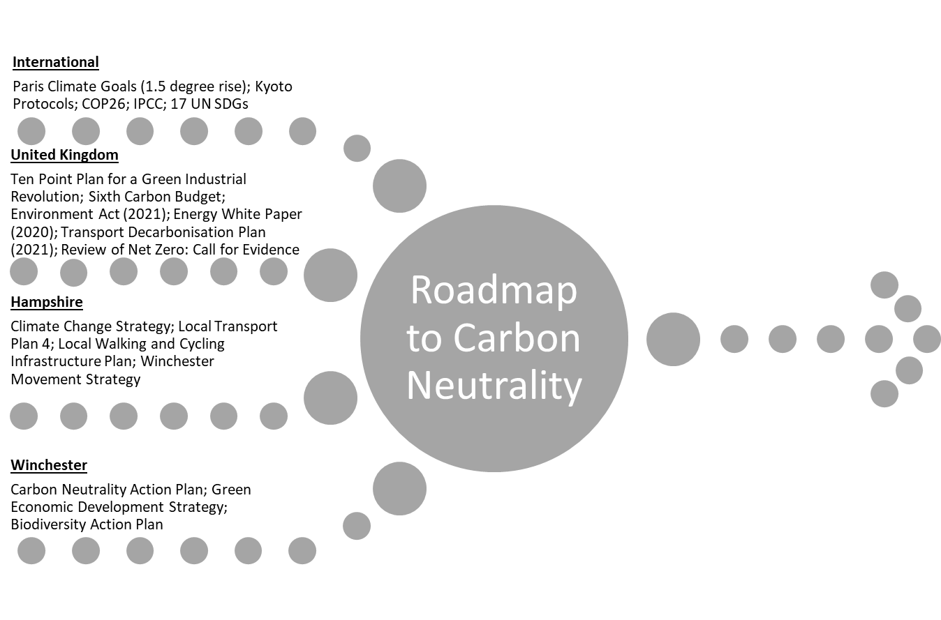

Energy
- Reduction in energy emissions is largely the result of grid decarbonisation nationally; need to prioritise local renewable energy generation;
- Solar and heat pumps are market-ready alternatives that could be adopted on relatively short timeframes;
- Winchester City Council energy emissions are 1% of the district – carbon neutrality can only be achieved if industry and commercial sectors also decarbonise.
Transport
- High level of public support for active travel measures and edge-of-town delivery hub identified through WCC consultations.
- Air pollution and congestion are key concerns. EVs resolve air pollution locally but not congestion and emission savings are reliant on grid decarbonisation;
- 76% of Winchester traffic is caused by commuters – partnership with HCC needed as WCC is not travel authority
Buildings
- Minimum Energy Efficiency Standards (MEES) are raising the floor on housing standards;
- Retrofitting is a highly effective way to reduce emissions, tackle the cost-of-living crisis and potentially stimulate local economic growth if local materials and contractors are sourced;
- Working both through planning frameworks and in partnership with development sector, developers and planners need to be conscious of likely changes to building regulations and design in net zero features to be future proofed.
Waste & Recycling
- Winchester & Hampshire are behind national recycling targets;
- Changes to collections can impact behaviour and increase recycling rates;
- Support for re-use, circular and sharing enterprises reduces consumption-based emissions.
Land Use & Biodiversity
- Winchester is in a green and strategic location. 40% of the district is in the South Downs and land use has the potential to act as a carbon sink;
- The forthcoming Local Plan should identify sites which can couple food production with decarbonisation;
- Natural environments are crucial for physical, mental, and planetary health but face threats from development, agriculture and road building.

Our Approach to develop the carbon neutrality roadmap
WSP created an energy and carbon model for the Winchester district (based on WSP’s local authority tool). The model uses data and models from public agency and government sources to assess the district carbon emissions and identify the total impact of the actions needed to achieve decarbonisation goal. WSP completed a carbon in habitats assessment to estimate the district’s total carbon stock and carbon sequestration potential
WSP’s 4-step carbon neutrality methodological approach is briefly described below.

Summary of energy consumption and emissions baseline
WSP estimated energy consumption and associated carbon emissions following the approach described in the Methodology (Step 1). Carbon emissions are territorial estimates covering the emissions produced within the Winchester district geographical borders. Incorporating findings from stakeholder engagement into our analysis has provides understanding of the context of these estimates and future implications.

Energy consumption in Winchester District
The figure below presents the breakdown of energy consumption by fuel type in the district in GWh. It also shows consumptions trends overtime. This breakdown has been prepared using sub-national total final energy consumption data from BEIS (2021)
Figure 2. Winchester District Energy Consumption

Key findings from energy consumption analysis
- Energy consumption across the district in 2019 was approximately 3,568 GWh. This is a reduction of around 11% since 2005.
- Emissions from gas and petroleum have remained static overtime. Decarbonisation of the electricity grid means that emissions from electricity consumption have declined rapidly, a trend BEIS predicts will continue.
- To meet the Winchester District and UK carbon emissions targets, the district needs to prioritise drastic reduction in gas use in buildings and stop the use of petroleum in the transport sector.

Carbon emissions in Winchester District
Figure 3. Winchester District Carbon Emissions

Key findings from carbon emissions analysis
- In 2019, in emissions accounted for 634 KtCO2 and have reduced 42% since 2005.
- These emissions savings are primarily from electricity grid decarbonisation
- In 2019, 39% of emissions came from the transport sector, the highest emitting sector in the district, 29% of GHG emissions came from domestic energy consumption and 32% from commercial and industrial activities. Public sector emissions are considerably lower than other sectors.
- Emissions from petroleum consumption (most transport emissions) represents 52% of emissions, while there is an even split between combustion of natural gas results and electricity consumption of 23% of CO₂ emissions in 2019.
- To meet the Winchester District and UK carbon emissions targets, transport measures will have to be prioritised.

Impact of current actions and BAU interventions
As a first step to develop the roadmap of actions to achieve carbon neutrality by 2030, the impact on carbon dioxide emissions of existing actions and projects were reviewed. The following documents were included:
- Winchester Climate Emergency - Carbon Neutrality Action Plan 2020 - 2030
- WCC Carbon Neutrality Annual Report 2020-21
- WCC Carbon Neutrality Annual Report 2021-22
By 2030, Business-As-Usual (BAU) reductions represent a reduction of 170 ktCO₂ from baseline emissions. The BAU scenario considers policies, plans and trends for the district, if no other action was taken. These actions already represent a significant step change from the way things have happened in the past and would require continued effort in order to bring to fruition. Business-as-Usual (BAU) policies modelled include:
- Domestic Minimum Energy Efficiency Standard (MEES) – this regulation has been modelled as domestic buildings in the private rental sector needing to reach EPC C by 2025.
- Transport electrification, including ICE (internal combustion engines) sale ban in 2030. This has been based the National Grid’s Future Energy Scenario modelling; and
- Electricity grid decarbonisation – this has been estimated using the Treasury’s Green Book emissions factors.

Winchester District Current Actions and BAU Emissions for 2005-2019
The current planned actions modelled represent 7.5 ktCO2 avoided by 2030. These are not sufficient to reduce emissions by 2030 to carbon neutral. Figure 4 provides a graphic representation of the remaining emissions of implementing current actions. This Roadmap was commissioned to provide an additional set of interventions to complement planned actions.
- Actions modelled include transport actions such as develop an expanded network of EV charging points across the district – starting with up to 46 points on the council's own estate by 2024.
- Prompt action and bigger shifts in behaviour will reduce emissions further. Transport emissions are pre-eminent and switching to a mix of active travel, electric vehicles, rail, public transport, and reducing journeys will help the district decarbonise ahead of schedule. Interventions that consider climate behavioural change will have a big local impact.
Figure 4. Winchester Emissions Graph for Current Actions and BAU Interventions
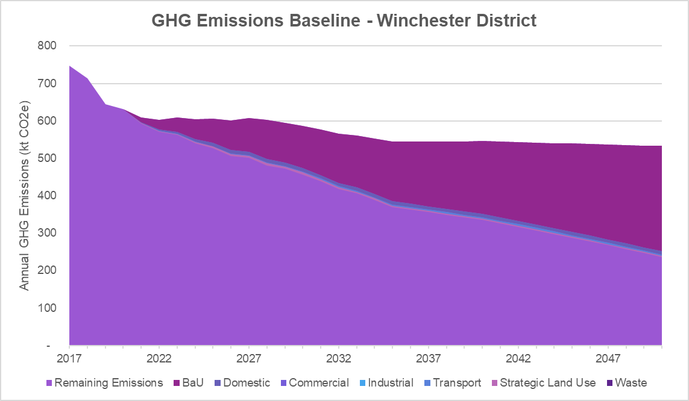
2030
Carbon Neutral by 2030
Key Findings from the energy-carbon analysis
WSP identified, modelled and quantified 16 roadmap interventions across domestic, commercial, industrial, transport, land-use and waste sectors to deliver carbon neutrality by 2030 in the Winchester district. Key findings include:
- Modelled CNAP actions represent 7.5 ktCO₂ avoided by 2030. These are not sufficient to reduce emissions by 2030 to carbon neutral. An additional 16 interventions have been modelled covering domestic, commercial, industrial, transport, land use and waste sectors.
- With proposed interventions implemented by 2030, Winchester will still need to offset 377ktCO₂ in 2030 to be on track to achieve carbon neutrality by the middle of the century. At the current market rate of £20/tCO₂ this will cost £7.54m to offset in 2030.
- The top 3 interventions based on carbon emissions reduction are on domestic, transport and land use PV sector:
  - Generating 50MW of utility scale solar PV installed on poorer quality land and onshore wind potential.
  - Invest in EV charging to decarbonise private cars and,
  - Install renewable heating measures to provide heating and hot water within domestic dwellings.
- By 2030, the district should have installed 50 MW of solar and wind power, generating the average annual energy demand of 3,100 UK households. This intervention also provides the greatest potential for emission reductions and financial savings.

Carbon in Habitats Methodology
WSP estimated the total carbon stock, total carbon flux, and change in carbon stored from the baseline stock up to 2030 and 2050 for habitats within Winchester district to estimate the carbon sequestration potential of the district and to support offsetting of remaining carbon emissions by 2030.
WSP’s 4-step carbon in habitats methodology is briefly described below.

Key Carbon in Habitats Findings
- The results show that the current amount of carbon stored across all of Winchester district’s habitats (which include, for example, woodlands, grasslands, and hedgerows) is 11,484.0 ktCO2, and that specifically for the Winchester district’s woodland the total storage is 8,103.8 ktCO2.
- The current projection for carbon stored in the Winchester district’s woodland shows that an extra 557.7 ktCO2 will be stored through carbon sequestration by 2030, and an extra 1,320.9 ktCO2 stored by 2050. This is based upon the current land area planted with trees i.e.,12,809 ha and assumes there are no significant changes to trees currently on the land (i.e., no trees are felled and re-grown).

Our Future Roadmap
Decarbonisation and achieving Winchester district carbon neutrality will require efforts across society. From parish councils to hospitals, employers to commuters, everyone must play their part.
Figure 5. Winchester District Carbon Neutrality Roadmap
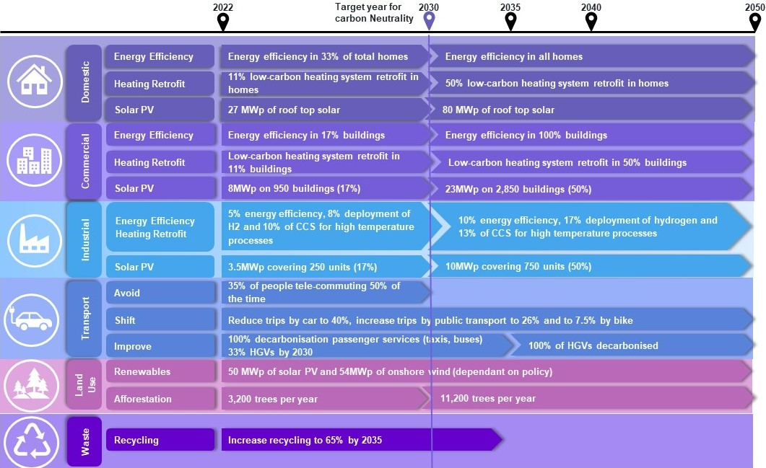
Current actions in the CNAP are not sufficient to achieve Winchester District carbon neutrality by 2030. Sixteen (16) interventions have been identified, designed and modelled across six sectors: domestic, commercial, industrial energy, transport, land use, and waste. Winchester will need to offset 377Kt carbon emissions in 2030 (remaining emissions in chart below) to achieve its carbon neutrality target at the current market rate of £20/tCO₂ this will cost £7.54m to offset in 2030.
This roadmap represents the medium scenario and already requires a significant increase of current efforts and pace of decarbonisation. WSP has included in the design that interventions will continue after 2030 in order to reduce offsetting require to maintain carbon neutrality in 2050.
In the chart below, each sector represents a combination of interventions, identified, designed and model by WSP. Additionally, the business-as-usual (BAU) and growth scenario includes interventions such as grid decarbonisation, vehicle electrification and minimum energy efficiency standards (MEES) regulation which contribute to emissions reduction.
Figure 6. Winchester Emissions Graph for Roadmap Interventions and BAU Interventions
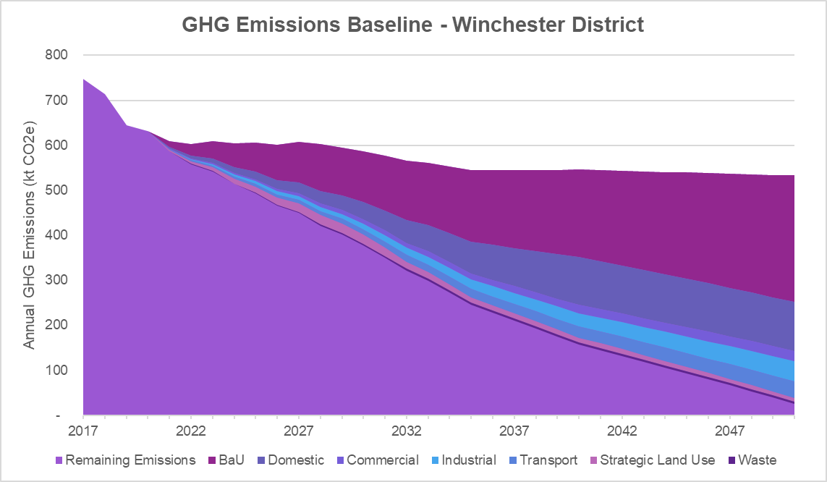
2030
Carbon Neutral by 2030

Summary of Roadmap Interventions and their Impact
The following table provides a summary of the carbon neutrality roadmap interventions for ease of comparison in terms of their delivery schedule for 2030 (target year for carbon neutrality) and 2050 (national goal for net zero GHGs), estimated carbon reduction by 2030 and estimated cost (and reduction).
- Costs estimates have been categorised low (£5-10m), medium (£15-50m), high (£90-200m).
- Cumulative carbon reductions estimate up to 2030 have been categorised low (0.1-10 ktCO₂), medium (17-43 ktCO₂), high (56-600 ktCO₂)
# | Intervention | Carbon saving | Cost | What?
Domestic
1 | Install domestic energy efficiency measures | 26ktCO₂ | Medium | - 2030: 18,000 homes (33%)  - 2050: 54,000 homes (100%)
2 | Install renewable heating measures | 68ktCO₂ | High | - 2030: 5,940 homes (11%)  - 2050: 27,000 homes (50%)
3 | Install solar PV on domestic dwellings | 22 ktCO₂ | Medium | - 2030: 27MWp yearly (powering 1,700 homes)  - 2050: 80MWp (powering 5,000 homes)
Commercial
4 | Install commercial energy efficiency measures | 44ktCO₂ | Medium | - 2030: 969 buildings (17%)  - 2050: 5,700 buildings (100%)
5 | Low carbon heating | 4ktCO₂ | High | - 2030: 600 buildings (11%)  - 2050: 2,850 buildings (50%)
6 | Install 8MW solar PV | 7ktCO₂ | Low | - 2030: 8MWp on 950 buildings (17%)  - 2050: 23MWp on 2,850 buildings (50%)
Industrial
7 | Support and mandate energy efficiency and heating retrofit measures | 60ktCO₂ | Medium | - 2030: 5% buildings with energy efficiency measures; 8% deployment of hydrogen; 10% carbon capture storage (CCS) for high temperature processes  - 2050: 10% buildings with energy efficiency measures; 17% deployment of hydrogen; 13% CCS for high temperature processes
8 | Support and incentivise solar PV | 3ktCO₂ | Low | - 2030: 3.5MWp covering 250 units (17%)  - 2050: 10MWp covering 750 units (50%)
Transport
9 | Promote hybrid working | 10ktCO₂ | Low | - 2030: 35% of people tele-commuting 50% of the time
10 | Improve active travel and public transportation infrastructure to reduce car journeys | 17ktCO₂ | High | - 2030: 50% of trips by car; 25% by public transport; 5% by bicycle  - 2050: 40% of trips by car; 26% by public transport; 7.5% by bicycle
11 | Decarbonise passenger service fleets (with HCC) | 56ktCO₂ | Medium | - 2035: 100% decarbonisation
12 | Work with local business and procurement to decarbonise freight | 34ktCO₂ | High | - 2030: 33% of HGVs decarbonised  - 2050: 100% of HGVs decarbonised
13 | Invest in EV charging infrastructure | 600ktCO₂ | High | - 2030: 16% of cars are EV and 4% of LGVs (11,400)  - 2050: 46% of cars are EV (32,700)
Land Use and Biodiversity
14 | 50MW of solar PV on poorer quality land and onshore wind | 147ktCO₂ | High | - 2030: 50MW generating power for 3,1000 homes; 54MW of onshore wind
15 | Plant 400 trees per year | 0.10ktCO₂ | Low | - 2030: 3,200 trees  - 2050: 11,200 trees
Waste
16 | 65% recycling rate | 18ktCO₂ | Low | - 2035: 65%

Economic Cost of the Roadmap Interventions
- Installing 50MW of utility scale solar PV installed on poorer quality land (ground mounted) or on roofs, and onshore wind potential provides the greatest emissions reduction potential and potential for financial savings.
- Supporting the installation of energy efficiency measures in offices, retail, and other commercial property types provides a significant carbon reduction per annual cost.
- Promoting hybrid working can be a low-cost way to reduce transport emissions (particularly for trips taken by private car). This action needs to be delivered alongside actions to address energy efficiency in homes and developing sustainable travel infrastructure.
- Installing renewable heating measures to provide heating and hot water within domestic dwellings provide a significant carbon reduction, however annual cost is one of the highest from all interventions, this doesn’t mean that this intervention should not be implemented, it means that emissions reductions will come at a net cost.

Flagship Actions
The sixteen recommended interventions will put Winchester district on a pathway towards carbon neutrality and the earlier and more significant interventions are made the more carbon emissions will be avoided and the sooner carbon neutrality achieved. The interventions with most significant carbon savings are:

Intervention 2: Install renewable heating measures to provide heating and hot water within domestic dwellings
What? | How?
Installing renewable heating measures for heating, cooling, and hot water in 11% of residential properties (approximately 5,940 homes) will avoid 68 ktCO₂ by 2030. Heat pumps are a market-ready alternative to boilers and will be suitable for many properties. They generate heat by transferring and compressing external thermal energy to provide heating and can also provide cooling by transferring internal heat outside. Air or ground source heat pumps (ASHP / GSHP) can be installed in new developments or existing properties to significantly decarbonise building heating/cooling | While council managed properties are a sensible starting point for this intervention, heat pumps increasingly make economic sense for homeowners and businesses on their own financial merits through savings on energy bills. Government support also exists, such as the Local Authority Delivery (LAD) scheme and Boiler Upgrade Scheme to help with upfront capital costs.

Intervention 13: Invest in EV charging to decarbonise private cars Investing in EV charging infrastructure
What? | How?
A comprehensive charging infrastructure throughout the district to enable 16% of cars to be electric by 2030 will avoid 600 ktCO2. This represents 11,400 cars in the district. Charge points should be installed in public car parks and private sector staff car parks. Not only will this support decarbonisation but will improve air quality, upskill the workforce and enhance economic opportunities by developing local supply chains. The average car is parked for 23 hours a day and could form the basis of a mobile battery network. Firms that install solar panels and electric chargepoints could allow employees to charge their EVs during the day with electricity fed back to the Grid in the evenings through vehicle-to-grid (V2G) chargers. This reduces the need for costly battery infrastructure and can be an additional source of income for both businesses and EV-owners. | Existing work with JoJu Solar, Mer and the Vaultrix car park provides a foundation for electric vehicle infrastructure in Winchester and this work needs to continue and be upscaled. The private sector can support the efforts by offering on-site EV charging and homeowners can take advantage of government grants to install chargers at home.

Intervention 14: 50MW of utility scale solar PV installed on poorer quality land
What? | How?
Renewable energy generation is key to the energy transition and installing the equivalent capacity for 3,100 UK homes will avoid 147 ktCO2 by 2030. Winchester, and the south coast, are ideally suited for solar panels with significant energy generation potential throughout the year. Wind and solar can help diversify farming incomes, community energy projects can increase delivery capability whilst retaining economic benefits local and can subsidise other projects, such as retrofitting and training courses. Installations will also develop supply chains, bringing further benefits to the local economy. Exciting co-benefits with solar installations are gaining attention, with the potential for co-locating solar arrays with grazing and crops. Solar panels can provide shelter from the sun and rain for livestock and, for some crops, have been shown to increase yields through water retention and shading, which is increasingly important as our summers become longer and drier. | Workshops with local farmers and landowners can identify land suitable for solar or wind installations as well as overcome potential objections during the planning process. Community Energy South can offer advice and support to community groups and parish councils to establish community energy projects.

Other interventions, such as retrofitting properties, decarbonising vehicle fleets, active travel choices, and energy efficiency measures will also bring significant carbon reductions. Retrofitting, energy efficiency measures, active travel choices and installing renewable energy technologies will bring savings and/or revenues so should be adopted by individuals and businesses throughout the district both to support carbon reduction ambitions and on financial merit. Grants, loans, and joint procurement can help reduce upfront capital costs.

Nature-based Recommendations
There is currently 11,484.1 ktCO2 stored in Winchester district’s habitats, with a potential to store an additional 557.7 ktCO2 through carbon sequestration by 2030. Winchester is a rural district that includes the South Downs National Park and protecting and enhancing biodiversity, ecosystem services, and carbon sequestration are a core part of the district’s future. Only newly planted trees can be counted towards offsetting budgets, as per Woodland Carbon Code guidelines. The target of 400 trees planted per year will sequester 0.1 ktCO2 by 2030.

Although these recommendations cannot currently be quantified, there are four recommended nature-based interventions that will further support the district’s environmental management approach:

Next steps
The roadmap to Carbon Neutrality has been developed for the Winchester District to enable stakeholders across the district to work towards meeting this ambitious 2030 target. The carbon neutral roadmap for the district is intended to support and influence the delivery of interventions and projects to achieve carbon neutrality by 2030. By adopting the roadmap, Winchester City Council will need to align its economic development, planning, and environmental management with resilient, low-carbon future, and support projects that ensure a low-carbon, inclusive future for the district.

Enabling mechanisms
While the WCC plays a key role in many of the interventions set out in this roadmap, collaboration across sectors and scales of governance is vital in achieving carbon neutrality targets. Each intervention set out in this document includes information on what organisation/s is best placed to lead its implementation as well as highlighting key partners and co-benefits.

To progress the roadmap, WCC will need to prioritise and plan for delivery. This will include working with the relevant delivery partners to undertaking detailed assessment of the interventions and develop delivery plans and investment cases. At a strategic level, WCC will need to consider how it uses this roadmap and evidence base to inform its future priorities, investment approaches, and wider governance arrangements. This will be key to enabling comprehensive and shared delivery of the roadmap actions and for achieving buy-in from key partners, national government, stakeholders, and citizens.

Future policies and plans should also take account of the roadmap and work to build on the evidence base developed as part of this work.

Offsetting recommendations
Emissions should be reduced as far as possible with offsetting used as to counter remaining emissions. There are several “hard to reach” emissions, such as transport, building heating and cooling, and embedded emissions that may require offsetting to achieve carbon neutrality by 2030. To comply with offsetting standards, WCC could purchase credits through the UK Woodland Carbon Code, which is the quality assurance standard for woodland creation projects in the UK, or the Peatland Code. These markets are established and would enable emissions to be offset within the UK. There are currently two accredited schemes on the south coast, in Dorset and West Sussex, and WCC could work with project developers and interested local parties to potentially support a similar scheme within Hampshire.

Glossary
Anthropogenic emissions: Emissions of greenhouse gases (GHGs), precursors of GHGs, and aerosols, caused by human activities. These activities include the burning of fossil fuels, deforestation, land use and land use changes (LULUC), livestock production, fertilisation, waste management, and industrial processes.
Biodiversity: or biological diversity means the variability among living organisms from all sources including, among other things, terrestrial, marine and other aquatic ecosystems, and the ecological complexes of which they are part; this includes diversity within species, between species and of ecosystems.
Business as Usual (BAU): BAU projections are based on the assumption that operating practices and policies remain as they are at present.
Carbon dioxide (CO₂): A naturally occurring gas, CO₂ is also a by-product of burning fossil fuels (such as oil, gas and coal), of burning biomass, of land use changes (LUC) and of industrial processes (e.g., cement production). It is the principal anthropogenic greenhouse gas (GHG) that affects the Earth’s radiative balance.
Carbon Neutrality: The Roadmap uses the Carbon Neutrality Action Plan (CNAP) definition of carbon neutrality as “having a net zero carbon footprint, refers to achieving net zero carbon emissions by balancing a measured amount of carbon released with an equivalent amount sequestered or offset”.
Carbon Offsets: A carbon offset is a reduction in emissions of carbon dioxide or other greenhouse gases made in order to compensate for (“offset”) an emission made elsewhere
Carbon sequestration: The long-term removal of carbon dioxide (CO₂) or other forms of carbon from the atmosphere, with secure storage on climatically significant time scales (decadal to century). The period of storage needs to be known for climate modelling and carbon accounting purposes.
Climate change: a change of climate which is attributed directly or indirectly to human activity that alters the composition of the global atmosphere and which is in addition to natural climate variability observed over comparable time periods.
Co-benefits: The positive effects that a policy or measure aimed at one objective might have on other objectives, thereby increasing the total benefits for society or the environment. Co-benefits are often subject to uncertainty and depend on local circumstances and implementation practices, among other factors.
Decarbonisation: Decarbonisation denotes the declining average carbon intensity of primary energy over time.
Enabling mechanisms: Enabling mechanisms are management and other approaches that engender execution in accordance with policy and planning intent (Peltz, Eric, et al, 2012).
Greenhouse gases (GHG): Gaseous constituents of the atmosphere, both natural and anthropogenic, that absorb and emit radiation at specific wavelengths within the spectrum of radiation emitted by the Earth’s ocean and land surface, by the atmosphere itself, and by clouds. This property causes the greenhouse effect. Water vapour (H2O), carbon dioxide (CO₂), nitrous oxide (N₂O), methane (CH₄) and ozone (O3) are the primary GHGs in the Earth’s atmosphere.
Pathways: The temporal evolution of natural and/or human systems towards a future state. Pathway concepts range from sets of quantitative and qualitative scenarios or narratives of potential futures to solution-oriented decision-making processes to achieve desirable societal goals.
(Climate Change) Roadmap: A climate change roadmap is an ever-evolving document, which seeks to push the agenda for further action on climate change
Definitions taken from IPCC glossary reports unless otherwise stated.

This approach aligns with Territorial estimates are published by the Department for Business, Energy and Industrial Strategy (BEIS), are used to monitor net zero and other UK-wide targets. These estimates include emissions produced within the UK’s geographical borders.
BEIS, 2021, Sub-national total final energy consumption data. Available online at: https://www.gov.uk/government/collections/total-final-energy-consumption-at-sub-national-level
BEIS, 2022 (accessed), Domestic private rented property: minimum energy efficiency standard - landlord guidance. Available online: https://www.gov.uk/guidance/domestic-private-rented-property-minimum-energy-efficiency-standard-landlord-guidance
National Grid, 2020, FES Documents archive. Available online: https://www.nationalgrideso.com/future-energy/future-energy-scenarios/archive
BEIS, 2021, Green Book supplementary guidance: valuation of energy use and greenhouse gas emissions for appraisal. Available online at: https://www.gov.uk/government/publications/valuation-of-energy-use-and-greenhouse-gas-emissions-for-appraisal
https://www.jstor.org/stable/10.7249/j.ctt1q60t9.13
https://www.ipcc.ch/

