Winchester City Council

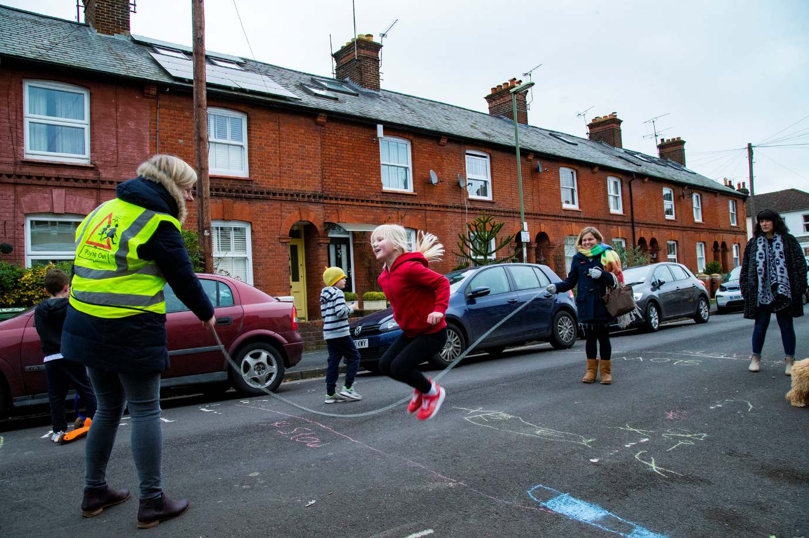

PLAYING OUT ROAD CLOSURE APPLICATION GUIDANCE

Version 1.0

Applications for a Temporary Playing Out Road Closure

You can apply to Winchester City Council to make a temporary road closure order to allow children to ‘play out’ in the street. The application can include up to 12 sessions for a road, or part of road, in any calendar year. The sessions cannot be longer than 3 hours each, and must be in daylight hours. They must be for the purpose of children playing in the street.

You will need to apply to us for a road closure at least 10 weeks prior to the date of the first event so that we have time to review your application and process the legal order. Winchester City Council cannot guarantee that an Order will be made, and any Order made under this application will be revoked if any of the Council’s current Road Closure requirements are not met.

If you are thinking of holding a Playing Out session in your road then please contact our Community Engagement Officer communities@winchester.gov.uk or Tel. 01962 848518 to ensure some basic steps such as consulting with neighbours has been undertaken prior to making an application. There is more information on temporary road closure applications on the Temporary road closure for events page.

1. Playing Out Sessions
A Playing Out session is a resident-led, outdoor, street play activity for the purpose of children’s play. It is independent from the Council and requires parent /adult supervision to ensure children’s safety. The road is temporarily closed and car access is restricted (but not stopped – residents take turns to 'steward' cars needing access to or from their properties). Suitable ‘Playing Out’ streets are usually quiet residential roads or cul-de-sacs and should be reopened no later than sunset.

Playing Out is the Bristol-based organisation who started this idea and can provide guidance and resources to anyone wanting to do it on their street.
To find out more, please visit www.playingout.net

This video by Playing Out gives a good idea of what’s involved in setting out and managing a temporary road on a quiet residential road.

For further information on temporary road closure applications for events please see the ‘Event Road Closure Application Guidance’. It’s in the documents section of the Temporary road closure for events page explains the information required for a road closure application in more detail.

2. What permissions and licences are needed?
Typically a Playing Out session will involve a temporary closure the street on which the session is being held. To do this, you need to submit an application for a temporary road closure at least ten weeks before the event is due to take place.

No activity requiring any form of license (under the Licensing Act 2003) may be undertaken when this Order is in force.

An Order is made entirely for the purposes of children’s free play and may not involve the placement of any structure (e.g. bouncy castles or stalls) on the highway during its use.

3. Plan of area to be closed
As part of application process for the road closure you will need to provide a plan of the area that is subject to the road closure. The plan/s must also include the location of barriers, signs and also diversion and emergency vehicle routes. Google maps https://www.google.co.uk/maps is ideal for this, but there are others you can use.

Please also see the ‘Event Road Closure Application Guidance’, in the documents section of the Temporary road closure for events page.

4. Barriers / Signs
The applicants must themselves provide, erect and dismantle barriers and signs which clearly show that the road has been closed. The design of the signs must be legally compliant and installed at each point of closure. They must be clearly visible to approaching motorists before they enter the road which is closed, to avoid the possibility that vehicles will be reversing and turning in confined areas.

Remember that members of the public cannot stop traffic to close a road, the signs are directing the traffic, so wait until there is no traffic approaching and then put out your road closed signs.

Each closure point must be supervised and maintained at all times by responsible and clearly identifiable adults.

Vehicular access for emergency services / residents / businesses must be maintained throughout any closure period. All vehicles must be walked through the closure by a responsible adult.

It may be possible to arrange to borrow the necessary signs from the Council, under an agreement. Once the signing requirements for your application have been agreed we will put you in contact with the relevant department to discuss sign availability. If we are able to lend any organisers will need to collect & return the items from the Council’s depot.

Alternatively, there are many companies selling banners or rigid plastic signs of suitable design for use in daylight hours.

5. Insurance
Winchester City Council do not require you to take out third party insurance for the purposes of street play. You will, of course, be responsible for the safety of your event and you may wish to take out insurance based on your assessment of risk.

We strongly advise that you carry out a risk assessment (See 6. Temporary Playing Out Road Closure FAQs): think about minimising risks from traffic, electricity, games, rain, etc. Agree in advance that everyone should take responsibility for themselves, their own children (as normal), and watch out for each other, especially children - you might say this on your invitation. See also the insurance section of https://www.streetparty.org.uk/insurance-for-street-parties/ for more information.

6. Temporary Playing Out Road Closure FAQs and checklist

Q. How do I tell people about the Playing Out session?
A. Ideally talking to people face to face is preferable if you want to get people involved. However, please ensure that you adhere to any Covid-19 restrictions that may be in place at the time. You also need to show the Council that you have “consulted” with your neighbours prior to applying e.g. by sending a resident consultation letter (See below for template). Temporary Playing Out Road Closures are for residents of your street and neighbouring streets only and there is no outside “publicity” (that would make it a public event). Remember to include any local businesses in your consultation if they would be affected by your road closure.

Q. Who organises the Playing Out session?
A. There should be a lead person from the street who can apply for the road closure order on behalf of the residents. This person should also be the main contact for the Council and the Emergency Services.

Q. How long should a Playing Out session last?
A. Play Street sessions take place on the weekend or after school allowing children the space to play out. No closure may be of more than 3 hours duration and the road can only be closed during daylight hours. These short sessions should not be confused with longer closures such as Street Parties.

Q. Do we need insurance cover?
Please see section 5. Guidance notes above.

Q. Do I need a Risk Assessment?
A. A formal risk assessment is not a legal requirement for a residents’ event such as this. However, we would recommend doing a simple risk/benefit exercise, to help think it through and for your own peace of mind. A good example of a Risk Assessment Template can be found on the Playing Out website here https://playingout.net/play-streets/useful-stuff/

Q. How do I close the road?
A. After reading this guidance you need to fill out the accompanying Road Closure application form at least ten weeks before the date of your first session.

You also need to provide a plan which details the length of road to be closed, sign and barrier locations (see section 4. above). A simple hand drawn map which indicates house numbers that the closure will take place between will suffice.

You must have a road closure order in place the close the road. Laminated copies will be sent to you a minimum of 2 weeks before the proposed date of your first session, with a plan of where they should be displayed. The order will specify the lengths of road(s) and times when you can close the road.

Signing should be installed by competently trained people. This video by Playing Out gives a good idea of what’s involved in setting out and managing a temporary road on a quiet residential road. Various Traffic Management companies offer short training courses.

Q. Do I need to have marshals?
A. Although there is no need to employ qualified persons to marshal your event, they should be briefed by a competent person (see above question). Stewards should wear a suitable reflective tabard. There should be two stewards or marshals at each road closure point to answer any questions from vehicle drivers, alert those within the closure of approaching vehicles, and walk through any vehicles wishing to enter or leave the closed section of the road

Q. Do we need to clean up afterwards?
A. Yes, you will need to clean up after your session. It’s your street, so keep your local area clean and tidy. Remember that the clean-up time should be considered when applying for the road closure order so that the clean-up can be safely undertaken while the road is closed, including removing any signs and barriers.

7. What do I need to do now?
1. Start by asking a couple of neighbours you know whether they are keen and discuss ideas. Agree a date / dates early on.

2. Invite the whole street to an initial meeting, ideally in the street as it is more welcoming, or try different houses to meet. Discuss the chosen dates and gather together everyone’s contact details. A couple more meetings might be needed to chat and plan. Someone could take notes of who is doing what and to copy invitations to all houses. Keep meetings informal and share out the activities and jobs – don’t let anyone dominate.

3. Decide who is going to be the lead resident and use the Template Consultation letter (below) to notify all affected properties of your plans to hold a Street Play session. Allow residents some time to raise any concerns.

4. Complete the online road closure application form for a Charity Event Road Closure. You will need to upload the plan showing the area to be closed and the signing/barrier information. Make sure that this is done at least ten weeks before your session.

Template Consultation Letter to residents
To: Resident From:
Address:
My tel. no:
…………………………….. ……………………………..

………………………………..

………………………………..

………………………………..

My e-mail: ……………………………….. Date: ………………………………..

Dear Neighbour,

Re: Proposed Temporary Playing Out Road Closure

I am hoping to organise a Play Streets event which means applying for Temporary Playing Out Road Closure on the following road(s):
……………………………………………………………………………………………………………
……………………………………………………………………………………………………………
On dates and times…………………………………………………………………………………..
This Order would only be valid at the above times ..... and subject to Council approval.

A Temporary Playing Out session is a resident-led, outdoor free street play activity for the purpose of children’s play.

The road will be fully closed to through traffic and points of closure will be marshalled. Residents will be allowed full access but are requested to drive at walking speed when within the closure area. It is not necessary to move parked vehicles from the street. Events will be under adult supervision and access will be maintained for emergency services at all times in all parts of the street(s). Parents will be fully responsible for their own children’s safety and behaviour.

I understand that you may have some initial concerns so please do contact me in the first instance with any comment, queries or objections regarding this proposal. If I cannot resolve your concern I will refer traffic related concerns to WCC traffic team on trafficteam@winchester.gov.uk, and non traffic related ones to communities@winchester.gov.uk

Please do not hesitate to contact me if you wish to offer support with organising or arrangements on the day.

Many thanks in advance for your co-operation.

Yours faithfully,

…………………………..

