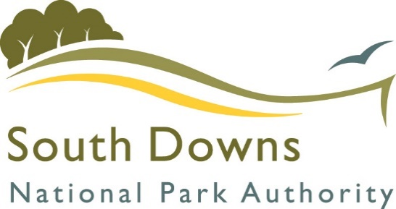

TWYFORD NEIGHBOURHOOD DEVELOPMENT PLAN REFERENDUM

INFORMATION FOR VOTERS

About this booklet
On 13th January 2022, there will be a referendum on a neighbourhood development plan for your area. This booklet explains more about the referendum that is going to take place and how you can take part in it. In this booklet, you can find out about:

- The Planning System
- The Development Plan [of which neighbourhood development plans are part]
- The neighbourhood development plan
- The neighbourhood area
- The referendum and how you can take part

The Planning System
The planning system manages the use and development of land and buildings. It exists to ensure that development is in the public interest and contributes to the achievement of sustainable development. This means ensuring that meeting the needs of the present do not compromise the ability of future generations to meet their own needs. It also means protecting and enhancing the built and natural environment while allowing growth that balances supporting the economy and community needs for homes, jobs, transport and infrastructure.
The planning system has two main parts:
- Plan making – setting out proposals for development and policies to guide development over time.
- Managing development – where development is agreed through the granting of planning permission.

Not all forms of development require planning permission as some building operations, depending on their scale and type, are covered by permitted development rights. For development that requires planning permission the South Downs National Park Authority (SDNPA) is responsible for deciding whether the development should go ahead. Decisions on planning applications in the Twyford area are based on the National Planning Policy Framework, the Development Plan for the SDNPA and any other material considerations that affect the decision. Decisions on planning applications in the National Park will also take into consideration the National Park Authority’s two purposes and duty specified in the Environment Act 1995:
Purpose 1: To conserve and enhance the natural beauty, wildlife and cultural heritage of the area.
Purpose 2: To promote opportunities for the understanding and enjoyment of the special qualities of the National Park by the public.
Duty: To seek to foster the social and economic wellbeing of the local communities within the National Park in pursuit of our purposes.
The DEFRA Circular on English National Parks and the Broads (2010) provides guidance to national park authorities on how to achieve their purposes and duty.

National Planning Policy Framework
In July 2021, the Government published the revised National Planning Policy Framework (NPPF). It sets out the Government’s planning policies for England and how these are expected to be applied. The framework gives guidance to local planning authorities in drawing up development plans and on making decisions on planning applications. The NPPF states that great weight should be given to conserving landscape and scenic beauty in national parks, which have the highest status of protection in relation to landscape and scenic beauty along with the Broads and the Areas of Outstanding National beauty (AONB). The NPPF is available as an on-line resource, together with associated planning practice guidance, at National Planning Policy Framework (publishing.service.gov.uk)

What is a Development Plan?
In England, local planning authorities determine planning applications in accordance with the Development Plan. A Development Plan is a set of documents that set out the policies for the development and use of land across the entire local authority area. The South Downs National Park Authority must prepare a local plan which sets planning policies within the local planning authority area. Local plans must be prepared with the objective of contributing to the achievement of sustainable development. They must be positively prepared, justified, effective and consistent with national policy in accordance with the Planning and Compulsory Purchase Act 2004 (as amended) and the National Planning Policy Framework.
Decisions must be made in accordance with the local Development Plan, unless material considerations indicate otherwise. The local Development Plan for the Twyford area consists of the South Downs Local Plan and the Hampshire Minerals and Waste Local Plan 2013. These documents are available via the following links:
- South Downs Local Plan
https://www.southdowns.gov.uk/wp-content/uploads/2019/07/SD_LocalPlan_2019_17Wb.pdf

- Hampshire Minerals and Waste Local Plan 2013
http://www3.hants.gov.uk/mineralsandwaste/planning-policy-home.htm

Once adopted, the Twyford Neighbourhood Development Plan will also be part of the local Development Plan.

What is Neighbourhood Planning?
The Localism Act 2011 introduced Neighbourhood planning to give local communities more control in the planning of their neighbourhoods. New rights and powers were introduced to allow local communities to shape development in their local area. The Act enables communities to develop a shared vision for their neighbourhood and deliver the sustainable development they need through planning policies relating to the development and use of land.
Who can prepare a Neighbourhood Development Plan?
Town or parish councils or neighbourhood forums can prepare a Neighbourhood Development Plan. The Twyford Neighbourhood Plan Steering Group, consisting of local volunteers and Twyford Parish Councillors prepared the Twyford Neighbourhood Development Plan.

What is a neighbourhood area?
A neighbourhood area can cover single streets or large urban or rural areas. The boundaries of a neighbourhood area are put forward by:

- Town or parish councils
- A neighbourhood forum (a group of at least 21 people in areas without town or parish councils)

In Twyford, the boundary of the neighbourhood area is identified on the map below and is identical to the parish area of Twyford.

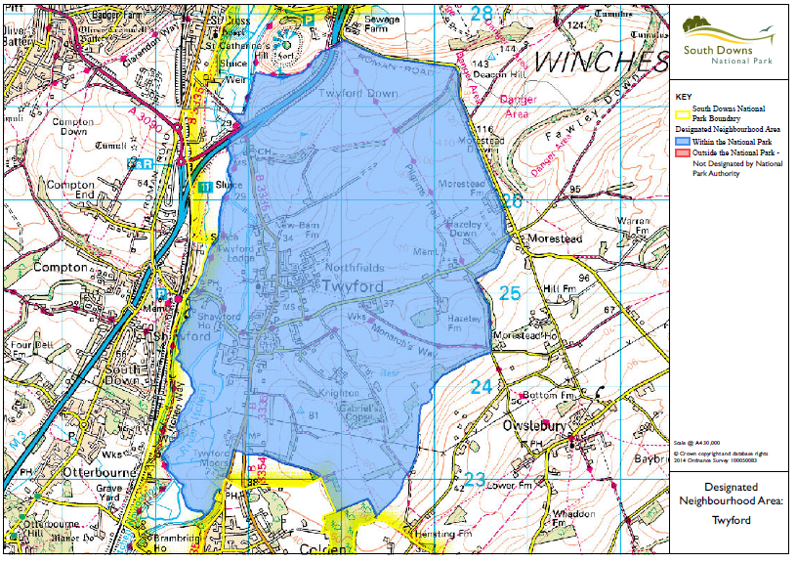

Neighbourhood Planning in Twyford
A Neighbourhood Development Plan (NDP) for Twyford has been prepared by a steering group set up by Twyford Parish Council, and contains a series of planning policies, which will guide development in Twyford up to the year 2033. The Twyford NDP includes policies on landscape and views, residential development, local heritage and community facilities amongst other topics. The NDP can be viewed at: Twyford Neighbourhood Plan - South Downs National Park Authority

Referendum on the Neighbourhood Development Plan
A referendum asks you to vote ‘yes’ or ‘no’ to a question. For this referendum, you will receive a ballot paper with this question:

"Do you want the South Downs National Park Authority to use the neighbourhood development plan for the Parish of Twyford to help it decide planning applications in the neighbourhood area?"

How do I vote in the referendum?
You vote by putting a cross (X) in the ‘Yes’ or ‘No’ box on your ballot paper. Put a cross in only one box or your vote will not be counted.

If more people vote ‘yes’ than ‘no’ in this referendum, then the South Downs National Park Authority will adopt the Neighbourhood Development Plan and use it to help decide planning applications in Twyford.

If more people vote ‘no’ than ‘yes’, then planning applications will be decided without using the Neighbourhood Development Plan as part of the Development Plan for the local area.

Referendum Expenses
Expenses can be incurred by an individual or body during the period of the referendum for the purposes of campaigning in association with the referendum. The Referendum expenses limit that will apply in relation to the Referendum is £2436.69. The number of persons entitled to vote in the Referendum by reference to which that limit has been calculated is 1266.

Specified documents

The relevant regulations state that the following documents must be made available:

- The referendum version of the Twyford Neighbourhood Development Plan;
- The report of the independent examiner on the draft Twyford Neighbourhood Development Plan;
- A copy of the written representations submitted to the independent examiner;
- A Decision Statement of South Downs National Park Authority’s satisfaction that the draft Twyford Neighbourhood Plan meets the basic conditions specified by statute and complies with the provision made by or under Section 38A and 38B of the Planning and Compulsory Purchase Act 2004;
- A statement that sets out general information as to town and country planning including neighbourhood planning and the referendum (Twyford Neighbourhood Development Plan: Information for Voters, document)

All the above documents can also be viewed on the South Downs National Park Authority website at:
Twyford Neighbourhood Plan - South Downs National Park Authority

Can I vote?
A person is entitled to vote if at the time of the referendum, they meet the eligibility criteria to vote in a local election for the area and if they live in the referendum area. Everyone on Winchester City Council’s electoral register (at the date of the vote) within the referendum area is entitled to vote. The eligibility criteria to vote are:

- you are registered to vote in local council elections; and
- you are 18 years of age or over on 13 January 2022

You have to be registered to vote by midnight Wednesday 22 December 2021 to vote in the referendum. The referendum will be conducted based on procedures, which are similar to those used at local government elections.

How to vote
There are three ways of voting:

In person on 13 January 2022
- At your local polling station. It is easy and a member of staff will always help if you are not sure what to do;
- You will receive a poll card confirming your polling station for this referendum;
- Polling stations are open from 7am to 10pm

By post
- If you have a postal vote already, you will receive a poll card confirming this
- If you want to vote by post, you will need to complete an application form and send it to the Electoral Registration Officer to arrive by 5pm on Thursday 23 December 2021 at this address:

The Guildhall,
City Offices,
Colebrook St,
Winchester
SO23 9LJ

Or via email: ereg@winchester.gov.uk

- Postal votes can be sent overseas but you need to think about whether you will have time to receive and return your completed postal vote by 13 January 2022;
- You should receive your postal vote about a week before polling day. If it does not arrive in time, you can ask for a replacement up to 5pm on 13 January 2022 by contacting our Helpline on 01962 848125. You do not need a polling card to vote.

By proxy
- If you have a proxy vote already, you will receive a poll card confirming this;
- If you cannot get to the polling station and do not wish to vote by post, you may be able to vote by proxy. This means allowing somebody that you trust to vote on your behalf;
- If you want to vote by proxy, you will need to complete an application form and send it to the Electoral Registration Officer to arrive by 5pm on Wednesday 5 January 2022 at this address:

The Guildhall,
City Offices,
Colebrook St,
Winchester
SO23 9LJ

- When you apply for a proxy vote, you must say why you cannot vote in person
- Anyone can be your proxy as long as they are eligible to vote and are willing to vote on your behalf. You will have to tell them how you want to vote.

Postal and proxy vote application forms are available from our Helpline on01962 848125 or by emailing ereg@winchester.gov.uk

Am I registered to vote?
If you are not registered, you will not be able to vote. You can check if you are registered by calling our Helpline on 01962 848125

To register to vote, you can go online to www.gov.uk/register-to-vote with your national insurance number by Midnight Wednesday 22 December 2021. If you do not have access to the internet, please call our helpline on 01962 848125.

How to find out more:
- Further general information on neighbourhood planning is available at: https://www.southdowns.gov.uk/planning-policy/neighbourhood-planning/

- For queries about planning issues and neighbourhood planning in general, please contact South Downs National Park Authority’s Neighbourhood Planning Team on neighbourhood@southdowns.gov.uk
You can find specific documents on the Twyford Neighbourhood Development Plan at: Twyford Neighbourhood Plan - South Downs National Park Authority

- For more information about voting and the arrangements for this referendum, please contact our Helpline on 01962 848125 or email: ereg@winchester.gov.uk

