Event Road Closure Application Guidance

- Event organisers responsibilities
As event organiser you are responsible for planning and holding the event safely and with minimum disruption to other highway users. You:
- must provide information on how the road closure will be managed, e.g. locations of any signs and barriers to be used, and emergency access arrangements (Traffic Management plan see below);
- are responsible for ensuring traffic management to implement the road closure (signage/barriers etc.) complies with relevant legislation (Traffic Signs Regulations and General Directions 2016 and Chapter 8 of the Traffic Signs Manual). This may require consulting a traffic management consultant;
- must ensure that the erection and dismantling of the required traffic management is carried out by competent and trained individuals, in accordance with Chapter 8 of the Traffic Signs Manual (on request WCC can provide a quote for this work);
- must contact all residents and businesses directly affected by the event in writing well in advance of the closure (ideally consulting before applying as well to gauge support);
- are responsible for arranging appropriate Public Liability Insurance (a minimum of £10million in any one claim) to provide protection to third parties who may be injured or harmed by or as a result of the event;
- must arrange for advance warning signs (AWS) to be erected, a minimum of one week, ideally 2 weeks, before the event, at each closure point. These signs should include information such as the start date and expected duration of closure, as well as a contact number for any enquires from members of the public. The text should be clear and concise as possible and ideally should read: ‘Road Closed here for (event) on [date], tel. [your telephone number]’;
- must ensure that access to premises within the closure is maintained at all times;
- must contact any bus companies whose services are affected by the closure;
- must contact the Winchester City Council waste collection service if the closure will affect bin collections.

- Prior Consultation
Ideally before applying, but certainly before an Order is made, the event organiser must consult with all the affected parties including directly affected local residents, emergency services, passenger transport companies, parish/town councils, etc. Details of all consultation including responses received and objections must be provided with the application.
Consideration should be given to the degree of disruption likely to be caused. Most events are of short duration and the disruption caused can usually be managed provided sufficient notification is provided.

- Traffic Management Plan
A Traffic Management (TM) plan is a document which explains how the traffic impacts of your event are going to be managed, e.g. signing so road users know an upcoming road is closed, and the diversion route (if one is required because it’s a busy, through road).
Signs on the highway direct and advise users of upcoming hazards and what is expected of them. Therefore they have to be of a consistent design and use, nationwide, this is ensured by following Traffic Signs Regulations and General Directions 2016 for sign design and Traffic Signs Manuals for their use.
The Traffic Signs Regulations and General Directions 2016 (TSRGD 2016) specifies all of the sign designs that are permitted to be used on the highway. Any signs used for your event should comply with the designs specified in the TSRGD 2016.
The Traffic Signs Manuals are government guidance on how the signs and road markings should be used. Chapter 8 refers to managing temporary situations on the road.
A good thing to keep in mind when considering what signing is required is:
NO ROAD USER SHOULD APPROACH IN ANY DIRECTION TOWARDS THE EVENT WITHOUT UNDERSTANDING EXACTLY WHAT IS HAPPENING
AND WHAT IS EXPECTED OF THEM

In terms of small events (e.g. street parties, playing out sessions, carnival parades etc.) the generally applicable parts of Ch.8 would be:
- Anyone setting out signs needs to be deemed ‘competent’ in accordance with Chapter 8 of The Traffic Signs Manual which provides the following definition:
“Competent person” means a person who has sufficient training and experience or knowledge and other qualities to enable him or her to undertake the task referred to.
- Advance Warning Signs – information sings to be erected, a minimum of one week, ideally 2 weeks, before the event, at each closure point. These signs should have a bright yellow background with black text, and include information such as the start date and expected duration of closure, as well as a contact number for any enquires from members of the public. The text should be clear and concise as possible and ideally should read: ‘Road Closed here for (event) on [date], tel. [your telephone number]’.
- Road Closed signs (Large red backbound with white text ‘Road Closed’)and cones or barriers at closure points.
- Road Ahead Closed signs may be necessary depending on the visibility of the closure point. Ideally these would be located at a junction prior to the closure so drivers have a choice to avoid the closure.
- Diversion signs If the road to be closed is a through road (not a dead end) then an alternative route should be signed using yellow background, black arrow
- All signs on the public highway must be placed so as not to obstruct sight lines at junctions, or obstruct vehicular or pedestrian traffic.
- Signs on the public highway must be removed safely as soon as possible after the event has cleared the road, but no later than two working days after the event.
- Only traffic marshals with police CSAS accreditations can direct traffic on the public highway. If no such marshals are available then any directions given to traffic must be provided by legal signs.
- Any signs placed on lamp columns on the public highway must obtain permission from the County Councils Street Lighting Contractor (tpa@sse.com)

Signs can be bought online or hired from various companies. Some website have signs that can be printed onto multiple sheets and stuck together. On request, WCC can quote for the loan of signs, if we have them available.
If you don’t know anybody appropriately trained to put the signing out (e.g. someone who works for a traffic management company), WCC can quote for putting out and taking down signing.
The content of the TM For smaller events this may just be a plan (print out from google or GIS plan produced by us on your request) with:
- the area of the closure marked (outlined or hatched)
- the locations of any signs Advanced Warning/ Road Closed/ Road Ahead Closed/ Diversion
- locations of any barriers, cones etc. to be used
- the diversion route (if one is required because it’s a busy, through road)
- PLUS an explanation of how the signing etc will be implemented (successful events are all down to planning), how resident and emergency access will be provided.

E.g. overleaf

Yellow highlighted section is area of closure
Red line is location of cones and ‘Road Closed’ sign
Black dot is location of the Advanced Warning Sign, put out 2 weeks before the event, on the street light (with SSE prior permission), and removed before the closure starts.
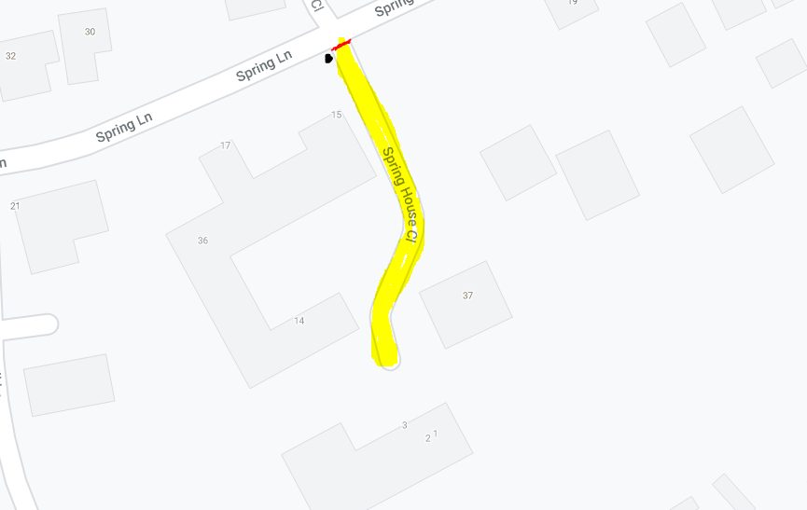
When the road is clear, the cones will be put across the road, with the Road Closed sign in front.
We will make sure that someone is always close enough to the closure point to move the cones/ sign if access is required by a resident or emergency services. If for resident access they will walk the car through the closure. If for emergency access they will alert anyone in the area to facilitate clearing the road.
Once our event is over we’ll remove the cones and signing, with appropriate care of the traffic.
- Advance notification of the closure
The impacts of temporary closures are minimised by good advance notification via-
- Prior Consultation (see above)
- Advance Warning Signs put up at closure points
- Information letters to affected properties providing contact information for the event organiser including emergency contacts for when the event is in operation.
- Depending on the appropriate road closure legislation advertisements in the local press and other media may be required, any costs will be borne by the event organiser (please see below)

- Arrangements for Access
Many events will disrupt access for residents and businesses in the affected area. The event organiser must include details of how access is to be maintained for these people in their Traffic Management Plan (see above).
If bus services are affected by an event road closure. The event organiser must liaise with the relevant public transport operators in sufficient time to effect route and/or timetable amendments.

- Access for Emergency Services
Event organisers should consider what will happen in the event of an emergency and what arrangements are necessary to allow emergency services onto or through the event site. Please consider both the possibility of emergencies happening at the event, or within the closure area, and include in the Traffic Management Plan.

- Public Liability Insurance
Public liability insurance of £10 million is required for all temporary road closures applications, except street parties and playing out sessions, to provide protection to third parties who may be injured or harmed by or as a result of the event.
For street parties and playing out sessions it is for the organisers to decide whether to arrange this cover. This following government webpage gives some guidance on the things to consider in this decision:
https://www.gov.uk/government/publications/can-do-guide-for-organisers-of-voluntary-events/the-can-do-guide-to-organising-and-running-voluntary-and-community-events#identify_how

- Our Application procedure

On receipt of your application we will check the information supplied is sufficient to understand why the road closure application has been made, and how the closure and event will be managed. If this is not clear from the provided information we will query this and it will delay processing of your application.

Once we have sufficient information to consult we will forward your application and supporting documents to the Highway Authority (Hampshire County Council for most roads, the Highways Agency for trunk roads)
Hampshire County Council (Highways Authority), the Police and Safety Advisory Group (SAG) for their comment.
- The Highway Authority will consider the effect of the event on the highway and highway users, and confirm if the roadspace is available. Hampshire County Council will check for clashes with any planned roadworks, who will try to postpone any that might be in the area.
- The Police may comment in relation to traffic management or public order/ safety concerns.
- SAG (all relevant agencies - HCC, Police, Public Health, emergency services) may comment to ensure public safety has been considered. This tends to be for larger or higher risk events, rather than street parties and carnival processions.

Please note whilst we will advise on your traffic management plan, ultimately you are responsible for ensuring it is legally compliant and suitable. It may be that a traffic management consultant would need to design it.

In terms of processing the legal order, providing:
- the use of roadspace has been confirmed acceptable by HCC,
- any safety concerns raised have been minimised,
we will draft an order permitting the road to be legally closed. For smaller events this is generally done under either S.21 Town Police Clauses Act 1847, or S.16A of the Road Traffic Regulation Act.

Please note if S.16A of the Road Traffic Regulation Act is used, we may require the event to be advertised in a local paper. This is decided on a case by case basis, depending on the scale of the event and the amount of advertising the event has. It is at the cost of the event organiser, and will be agreed in advance.
Once the Order has been made we will:
- confirm that the order legalising the temporary closure of the road, and the closure times, and
- provide laminated copies of the legal order which are to be put up on site at least 1-2 weeks before the event, we may opt to specify the locations.
The event organiser should also regularly check on the one.network website to identify any works that they might consider to have an impact on the event or traffic attending the event.
The Highway Authority retains the right to withdraw consent for the event should they receive significant objections prior to the event taking place.

Links to referenced documents:
The Traffic Signs and General Directions Regulations 2016
Traffic Signs Manual - Chapter 8 Part 1 - Design
Traffic Signs Manual - Chapter 8 Part 2 – Operation
Traffic Signs Manual - Chapter 8 Part 3 – Update

