Winchester City Council Community Grants Newsletter – June 2021
Welcome to the latest funding newsletter from the Community Grants team at Winchester City Council. Further information about all our grant schemes is available on our website. If you have any questions or would like to discuss an application, please don’t hesitate to get in touch: grants@winchester.gov.uk; 01962 848 256.
For the latest updates, follow us on Facebook and Twitter!
SMALL GRANTS SCHEME NOW OPEN – UP TO £500
This scheme has now reopened and is welcoming applications from across the Winchester district. Grants of up to £500 are available to local voluntary and community groups for one-off pieces of expenditure on projects, equipment and other items which will help your organisation to do more, reach more people, provide better services or try something different.
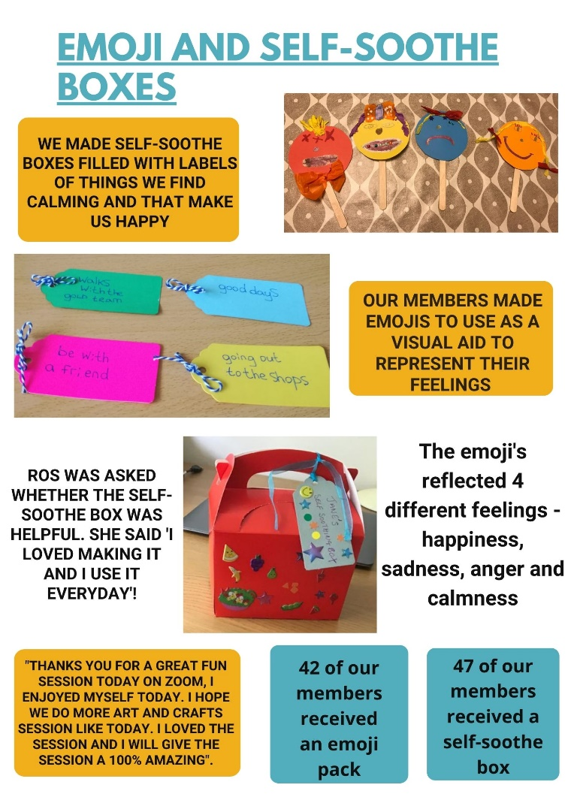
We have relaxed our criteria until 30 September 2021 to encourage organisations to apply for Coronavirus (COVID-19) related activities which support our themes of: Dealing with peoples and communities needs and striving for positive change. Examples of expenditure could be:

- Trialling a different way of working during socially distanced times
- Buying different or updated technology
- Increasing or updating your resources
- Improving digital connectivity to enhance service user engagement
- Activities to increase your support to vulnerable individuals
- Creating a COVID safe environment in which to deliver your service
- Provision of equipment including Personal protective equipment (PPE)
Feedback from Winchester Go LD who received a small grant earlier this year

The application process is easy! Please see our website for further details and information on how to apply.
CROWDFUND WINCHESTER – NEW CRITERIA
The council provides match funding support for organisations through Crowdfunder, and both businesses and not for profit organisations within the Winchester district are invited to apply. We have 2 funds open at present:

Communities Positive Change Fund

Does your organisation provide services or activities which deal with communities’ needs such as isolation, low income, homelessness, mental health and physical inactivity? Or perhaps you are striving for positive change in the Winchester district by increasing the use of digital applications, services and products, creativity, innovation and business growth opportunities. In addition for applications received until 30 September 2021, our relaxed criteria will apply to not for profit organisations. Funding can be sought to support additional costs incurred to deliver services or projects.

If your organisation is eligible, the council will consider matching up to 50% of the project costs or £2000 (whatever is less). Start Crowdfunding today by reading more on our website.

Greener Futures Fund - New! Business can also now apply to this fund.

We want to hear from organisations who can help to create a ‘greener’ Winchester district. Projects could address issues such as transport, energy consumption or behavioural changes.

Not for profit organisations and businesses can apply for match-funding of up to 50% of the project costs or £2000 (whatever is less). Read more on our website.

COMMUNITY FIRST
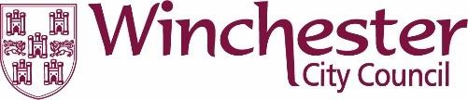
Through our partnership with Community First we provide targeted support and advice to voluntary, community and social enterprise organisations across the Winchester district. Why not take a look at their new website which is full of useful advice on topics such as funding, volunteering and training, along with the many other services they provide.

