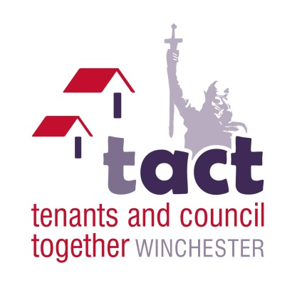

TACT Chairs Report 2021

As I approach completion of my four year tenure as TACT Chair, I wish to look back at the highs and lows of the past 15 months. Fortunately there have been more highs than lows, despite the Covid19 virus and all the changes it has brought with it.

Due to the Covid19 restrictions we have been unable to meet up face to face, which has been difficult for us as a group. Additionally, the sudden passing in August of our elected Communications Officer - Michael Fawcitt, was a sad and sudden occurrence. Also the incapacity of our Vice Chair - Sue Down has meant that the TACT Committee has been subject to lots of changes too. However, as Chair I have tried my best to keep things going as smoothly as possible.

With regards to Michael, his main focus was on Housing Finances, and he would always go over any financial papers with a fine tooth comb, highlighting everything in his yellow highlighter. He could therefore always be relied on to raise important matters relating to finances at cabinet meetings which we both attended.

Another sadness was the passing of Alan Rickman, who was Chair of TACT for many years but even after his retirement due ill health, he still continued to take a keen interest.

Despite these setbacks, one of the highs was the willingness of many TACT members to agree to sign up for virtual meetings, as this was the only option open to us to continue our discussions as a group during the pandemic. I am really grateful to those who took up the challenge and to Michelle Smith and Lucy Spence who trained them and enabled the meetings to be brought online. Equally, The TACT Committee and Tenant Involvement Team have also worked hard to continue gathering views from those of you not engaging virtually, through email and phone calls.

In March, TACT helped to facilitate a tenant consultation meeting requested by Cllr Learney, to discuss the provision of a Hardship Fund of £500k set aside from the HRA to help tenants struggling as a result of the pandemic. TACT fully consented to these funds being released, to help those experiencing job losses or other difficulties resulting from Covid19. The ‘Welfare Workshop’ included tenants present from all of the Involved Tenant groups, including SDGs and Readers Panel, and also feedback from tenants via email and phone. In total, 24 individual tenant opinions were included in the discussions and meeting report, which will directly contribute to the cabinet paper. The TACT Committee were pleased with the response from tenants and thank all TACT members who contributed.

Also in March, TACT members were advised that the way WCC Complaints were dealt with was under review. This was very encouraging to those TACT members who had been part of the scrutiny exercise on Communications, as improvements to the Complaints process was amongst 67 recommendations presented to WCC prior to the pandemic. It was pleasing to see that the Complaints feedback has directly impacted and influenced the approach for the review. Additionally a Complaints Focus Group for tenants has now been set up. A great result for us all.

We have also continued to take part in consultation on Fire Strategy, Asset Management, New Builds, Property Services (and the future plan on housing improvements), plus Refuse and Recycling issues. So more highs for us to take note of.

But we wouldn't be able to undertake some of these issues without the continued support of you - our TACT members - and your continued involvement and commitment. Also, the TACT Support Group who are in constant contact with myself. Also thanks go to Tenant Involvement and the support of council officers and Councillors, all who have made the past four years informative and enjoyable for me. I will miss the interaction with everyone.

Whoever is elected onto the committee I wish them every success, in particular the new Chair, and I will continue to offer my support in any way I can.

With thanks to you all and my best wishes,
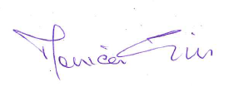

Monica Gill
May 2021

