A short guide to the new Housing Health Safety Rating System

Damp and mould growth
Health threat from dust mites, mould or fungal growths caused by dampness and/or high humidities. It includes threats to mental health and social well being from living with damp, damp staining and/or mould growth.
Most vulnerable: 14 years or less222

Excess cold
From sub-optimal indoor temperatures.3

Most vulnerable: 65 years plus

4
Asbestos (and MMF)
Caused by exposure to asbestos fibres and manufactured mineral fibres (MMF).

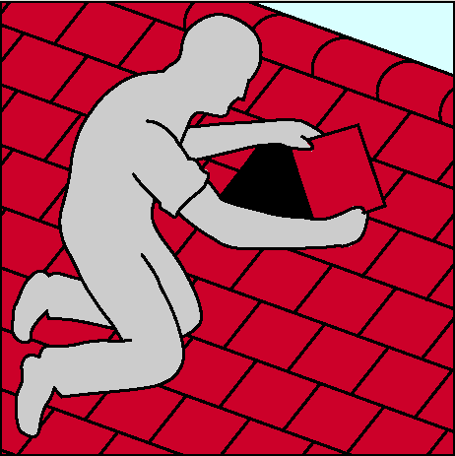

Most vulnerable: no specific group

Biocides
Threats to health from those chemicals used to treat timber and mould growth in dwellings. Insecticides and rodenticides to control pest infestations (e.g. cockroaches or rats and mice), these are not considered for the purposes of the HHSRS.
Most vulnerable: no specific group

Carbon monoxide and fuel combustion products
Hazards due to excess levels of carbon monoxide, nitrogen dioxide, sulphur dioxide and smoke in the dwelling’s atmosphere.

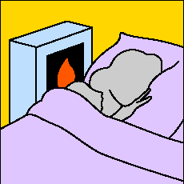

Most vulnerable: CO, 65 years plus. NO2, SO2 and smoke, no specific group

Excess heat
Caused by excessively high indoor air temperatures.
Most vulnerable: 65 years plus

8

Radiation
This category covers the threats to health from radon gas and its daughters, primarily airborne, but also radon dissolved in water. While rare, leakage from microwave ovens might also be considered. Evidence of health risks from low-level exposure to electro-magnetic fields from phone masts have not, to date, been proven.
Most vulnerable: all persons aged between 60 and 64 years who have had lifetime exposure to radon
10
Volatile organic compounds
VOCs are a diverse group of organic chemicals which includes formaldehyde, that are gaseous at room temperature, and are found in a wide variety of materials in the home.
Most vulnerable: no specific group
1
Lead
Threats to health from the ingestion of lead.
Most vulnerable: under 3 years

Entry by intruders
Problems keeping a dwelling secure against unauthorized entry and the maintenance of defensible space.

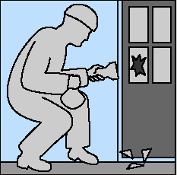

Most vulnerable: no specific group

Crowding and space
Health hazards linked to a lack of living space for sleeping and normal family/household life.
Most vulnerable: no specific group

Lighting
Threats to physical and mental health linked to inadequate natural and/or artificial light. It includes the psychological effect associated with the view from the dwelling through glazing.
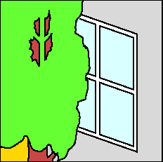

Most vulnerable: no specific group
14
Noise
Threats to physical and mental health caused by noise exposure inside the dwelling or within its curtilage.
Most vulnerable: no specific group
1

5
Domestic hygiene, pests and refuse
Health hazards due to poor design, layout and construction to the point where the dwelling cannot be readily kept clean and hygienic; access into, and harbourage within, the dwelling for pests; and inadequate and unhygienic provision for storing and disposal of household waste.

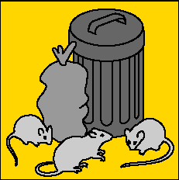

Most vulnerable: no specific group
16
Food safety
Threats of infection due to inadequate facilities for the storage, preparation and cooking of food.
Most vulnerable: no specific group
17
Personal hygiene, sanitation and drainage
Threats of infection and threats to mental health associated with personal hygiene, including personal washing and clothes washing facilities, sanitation and drainage.
Most vulnerable: under 5 years
18
Water supply for domestic purposes
The quality and adequacy of the water supply for drinking and for domestic purposes such as cooking, washing, cleaning and sanitation. Also, threats to health from contamination by bacteria, protozoa, parasites, viruses, and chemical pollutants.
Most vulnerable: no specific group
19
Falls associated with baths etc
Falls associated with a bath, shower or similar facility.
Most vulnerable: 60 years plus

20
Falls on the level
Falls on any level surface such as floors, yards and paths. It also includes falls associated with trip steps, thresholds, or ramps, where the change in level is less than 300mm.
Most vulnerable: 60 years plus
21
Falls associated with stairs and steps
Falls associated with stairs, steps and ramps where the change in level is greater than 300mm. It includes falls on internal stairs or ramps within the dwelling, external steps or ramps within the curtilage of the dwelling, internal common stairs or ramps within the building, access to the dwelling, and to shared facilities or means of escape in case of fire. It also includes falls over stair, step or ramp guarding (balustrading).
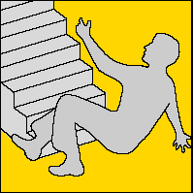

Most vulnerable: 60 years plus

Falls between levels
Falls from one level to another, inside or outside a dwelling, where the difference in levels is more than 300mm. For example, falls out of windows, falls from balconies or landings, falls from accessible roofs, into basement wells, and over garden retaining walls.
Most vulnerable: under 5 years
23
Electrical hazards
Hazards from electric shock and electricity burns, including from lightning strikes.

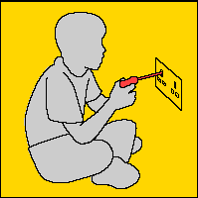

Most vulnerable: under 5 years
2

Fire
Threats from uncontrolled fire and associated smoke. It includes injuries from clothing catching alight, which appears to be common when people attempt to put out a fire. It does not include clothing catching alight from a controlled fire by reaching across a gas flame or an open fire used for space heating.
Most vulnerable: 60 years plus

Hot surfaces and
materials
Burns or injuries caused by contact with a hot flame or fire, and contact with hot objects or hot non-water based liquids, and scalds – injuries caused by contact with hot liquids and vapours. It includes burns caused by clothing catching alight from a controlled fire or flame.
Most vulnerable: under 5 years

Collision and Entrapment
This category includes risks of physical injury from:

a) trapping body parts in architectural features, such as trapping limbs or fingers in doors or windows.
Most vulnerable: under 5 years

b) striking (colliding with) objects such as architectural glazing, windows, doors, low ceilings and walls.
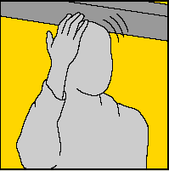

Most vulnerable: 16 years plus

Explosions
Threat from the blast of an explosion, from debris generated by the blast, and from the partial or total collapse of a building as the result of an explosion.
Most vulnerable: no specific group
28
Ergonomics
Threats of physical strain associated with functional space and other features at dwellings.

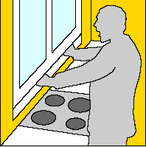

Most vulnerable: 60 years plus
29

Structural collapse and falling elements.
The threat of the dwelling collapsing, or of an element or a part of the fabric being displaced or falling because of inadequate fixing or disrepair, or as a result of adverse weather conditions. Structural failure may occur internally or externally.
Most vulnerable: no specific group

Uncombusted fuel gas
The threat of asphyxiation due to fuel gas escaping into the atmosphere within a dwelling.
Most vulnerable: no specific group

Each of the above HAZARDS has to be taken into account during any inspection.
Each of the hazards has a rating score, which has been devised by the ODPM as a likely score you would expect within an “average property”.

An officer will be looking for any deficiencies that would result in an increased likelihood of harm occurring to a vulnerable group due to the hazard identified as being worse than an average property, taking into account property type, age of the property and usage of the property i.e. being used as a House In Multiple Occupation.

HHSRS assesses twenty nine categories of housing hazard, including factors which were not covered or covered inadequately by the housing fitness standard. It provides a rating for each hazard. It does not provide a single rating for the dwelling as a whole or, in the case of multiply occupied dwellings, for the building as a whole. A hazard rating is expressed though a numerical score which falls within a band. There are 10 bands. Scores in Bands A to C are Category 1 hazards. Scores in Bands D to J are Category 2 hazards.

For more information, please contact the Private Sector Housing Team on 01962 848381

Reproduced with permission from:

