**Bus Access to the Winchester Sports & Leisure Centre**

**Existing Bus Access from the City Centre to WS&LC**

The site of the Winchester Sports and Leisure Centre (WS&LC) is currently served by the no4 Stagecoach bus service and by the Winchester Park and Ride (P&R) service.

The no4 provides an hourly circular service between Highcliffe, the city centre and Teg Down. It takes a clockwise route through Highcliffe from Bar End Road with the nearest bus stop to the leisure centre located on Milland Road, see Figure 1.

Figure 1 – No4 Route – City centre to Highcliffe

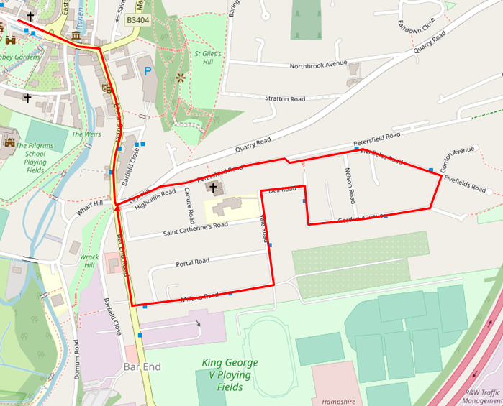

Table 1 shows that leisure centre users can access a bus service from the city centre to Milland Road using the no4 bus from 08.30, Monday to Friday, 09.30 on Saturdays and 09.43 on Sundays and public holidays. Journeys returning to the city centre run until 17.22, Monday to Fridays, 17.57 Saturdays and 16.46 on Sundays and public holidays. It has a peak frequency of one bus per hour.

Table 1 – No4 Bus Service

|  |  |  |  |  |  |  |  |  |  |
| --- | --- | --- | --- | --- | --- | --- | --- | --- | --- |
|  | **First bus from Broadway** | **Last bus from Milland Road** | **Peak Freq (per hr)** | **First bus from Broadway** | **Last bus from P&R Milland Road** | **Peak Freq (per hr)** | **First bus from Broadway** | **Last bus from Milland Road** | **Peak Freq (per hr)** |
|  | **Monday to Friday** | | | **Saturday** | | | **Sunday** | | |
| **No 4** | 08.30 | 17.22 | 1 | 09.24 | 17.57 | 1 | 09.43 | 14.46 | 1 |

The P&R service provides a high frequency service between the South P&R car park and St Catherine’s P&R car park, via the city centre and Barfield P&R car park, see Figure 2. The nearest bus stop to the leisure centre is located within the Barfield P&R car park.

Figure 2 – P&R Route – City centre to St Catherine’s P&R

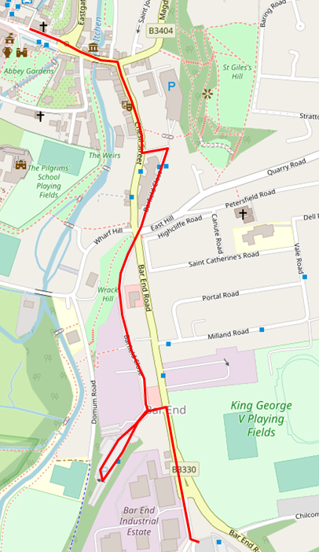

Table 2 shows that leisure centre users have access from the city centre from 06.46, Monday to Friday, and from 09.56 on Saturdays. There are no P&R services on Sundays or public holidays. Return journeys towards the city centre run until 19.23, Monday to Friday and 18.30 on Saturdays.

Table 2 – P&R Service

|  |  |  |  |  |  |  |  |  |  |
| --- | --- | --- | --- | --- | --- | --- | --- | --- | --- |
|  | **First bus from Broadway** | **Last bus from Barfield** | **Peak Freq (per hr)** | **First bus from Broadway** | **Last bus from Barfield** | **Peak Freq (per hr)** | **First bus from Broadway** | **Last bus from Barfield** | **Peak Freq (per hr)** |
|  | Monday to Friday | | | Saturday | | | Sunday | | |
| **P&R** | 06.46 | 19.23 | 5 | 07.10 | 18.30 | 5 | - | - | - |

Comparing the start and finish times of both services to the leisure centre operational hours (05.00 to 23.00), staff working the early or late shifts would be limited in their options to travel by bus, while leisure centre users would be limited in access by bus for the opening hour of 06.00 and later in the evening, after 18.30. There is currently no P&R service on Sundays while the no4 service finishes running early afternoon.

With regards to frequencies, the no1 does not provide an attractive regular service running on an hourly basis compared to the high frequency P&R service.

It should be noted that a number of changes are proposed to the P&R service over the next year. This includes the provision of a bus stop on Barfield Close which will reduce the walking distance to and from the bus to the leisure centre and connect into the new pedestrian crossing on Bar End Road. The service will also be improved with later running times and a Sunday service meaning that the P&R service would be a better service to promote for access to the leisure centre in terms of frequency and running times.

**Existing Bus Access into the City Centre**

Appendix A shows the existing bus services into the city centre along with their start and finish times and frequency. It demonstrates that the majority of services into the city run late into the evening between Monday and Saturday which would allow those using the leisure centre into the evening a return journey from the city centre. The exception is the no1 service to Winnall which stops running at 19.30 and the no69 service to Colden Common, Bishops Waltham and Wickham between Monday and Thursday where services stop at 18.55.

Frequencies of services range between one service an hour (no69 and no7) and six services per hour (no5) between Mondays and Saturdays.

On Sundays all bus services into the city centre run a reduced service. Services start running from the outer areas of the district between 07.54 (no5) and 09.37 (no66) and run until 17.50 (no64) and 19.40 (no5). The exception to this is the no1Bluestar which runs a Sunday service until 23.20. It should be noted that there is no Sunday service between the city centre and Wickham.

**Fares**

The leisure centre falls within the Stagecoach ‘Winchester Ticket Zone’, see Appendix B, which can be purchased from £4.60 for an adult or £8.50 for a family[1] ticket. Anyone travelling with a ‘Winchester Dayrider’ would not need to purchase a second ticket if travelling across the city to the leisure centre. Table 3 shows the different ticket types and prices.

When travelling from outside of the ‘Winchester Ticket Zone’ via Stagecoach services leisure centre users can purchase day returns of differing costs depending on their starting location or purchase a South Dayrider Gold, for £8.40 or families can purchase a Gold Family Dayrider from £16.00.

Table 3 - Daily tickets available to travel across Stagecoach and Bluestar sevices

|  |  |  |  |
| --- | --- | --- | --- |
| **Adult Ticket Type : no transfer ticket required** | **Online Fare** | **On Bus Fare** |  |
| **Stagecoach** | | | |
| City centre - Milland Road - single | - | £1.50 |  |
| City centre - Milland Road - return | - | £2.55 |
| City centre – Barfield P&R car park | - | £1.60 |
| **Stagecoach** | | | |
| Winchester Dayrider – adult | £4.60 | £4.80 | Winchester Zone |
| Winchester Dayrider – child | £3.30 | £3.50 |
| Winchester Family Dayrider | £8.50 | £9.20 |
| South Dayrider Gold - adult | £8.40 | £9.10 | Gold Zone |
| South Dayrider Gold - child | £6.60 | £7.10 |
| Gold Family Dayrider | £16.00 | £17.40 |
| Nightrider Gold | £2.50 | £2.50 | All zones |
| **Bluestar** | | | |
| Return between Otterbourne and city centre | - | £6.20 |  |
| **Stagecoach and Bluestar** | | | |
| Solent Go Day Travelcard – can be used on Bluestar and Stagecoach | - | £8.00 |  |

In addition to the daily tickets Stagecoach bus users with Megarider, term rider and student tickets will also be able to access bus services across the city to the leisure centre on the P&R and no4 services.

A return ticket on the Bluestar no1 from Otterbourne costs £6.20 for an adult and £3.40 for a child.

All Hampshire County Council older person and disabled person concession passes are accepted on services across the city after 09.30. Up to 2 children under 5 years of age are free to travel on the services.

A review of the fares shows that for residents who live in walking distance of the Pitt P&R car park, it is in fact cheaper to purchase a P&R ticket (with no need to park a car) than it is to pay for a Winchester Dayrider.

**Potential options to improve accessibility by bus**

*Reverse Route No 4 Service at Highcliffe*

Currently the number 4 service travels in a clockwise direction through Highcliffe, meaning passengers travelling to the leisure centre would pass via East Hill, Gordan Avenue disembarking at Milland Road. To ensure a faster journey time for leisure centre users it may be possible to reverse the bus route, with the first stop within Highcliffe being Milland Road.

The impact of reversing the route would be the relocation of existing bus stops to the opposite side of the roads within Highcliffe and potential changes to the existing / proposed TROs may be required.

*Split the No4 Service*

As previously discussed the no.4 service is also part of the circular route that serves Teg Down. The service is often criticised for running late as it is caught in congestion to the west of the city. Subject to discussion with Stagecoach the no4 service could be split and the Highcliffe route could be joined with the no1 route that serves Winnall while the Teg Down route of the no4 could be joined with the Stanmore route of the no1 with both travelling via the city centre. The existing routing is shown on Appendix B.

This would result in a bus route solely serving the east of the city connecting it to the city centre. It would also introduce a bus service allowing Highcliffe residents access to the Tesco supermarket at Winnall.

*Frequency*

However, neither of the above changes would address the low frequency of the service therefore an extension in service times and increase in frequency to every half an hour could be trialled to gauge its popularity in use.

*Extension of the Park & Ride Service*

As it already has a higher frequency and earlier start and later finish times users of the leisure centre could be actively encouraged to use the Park and Ride service to access the leisure centre. The on-board announcement system could be updated to include WS&LC as well as Barfield car park as a destination.

As previously discussed a number of changes are proposed to the P&R service over the next year. This includes the provision of a bus stop on Barfield Close which will reduce the walking distance to and from the bus to the leisure centre. The service will also be improved with later running times and a Sunday service meaning that the P&R service would be a better service to promote for access to the leisure centre in terms of frequency and running times.

However, the peak time P&R services are already busy and encouragement of leisure centre users onto those buses may cause capacity issues, especially during the winter months.

*Development of P&R App*

Although Stagecoach run an app providing details on journey planning, bus tracking and ticket purchases the P&R service is not included within this. It should be recommended that either the P&R service is included in the Stagecoach app or an individual app is developed for P&R which could be promoted by the leisure centre.

*Development of Leisure Centre ‘bus ticket’*

An opportunity into a P&R bus ticket associated to the leisure centre should be investigated. This could be a flat single fare for both children and adults of for example 50p, allowing bus travel between the P&R bus stops and the leisure centre and would include the stops located at:

* Royal Hampshire County Hospital
* Westgate
* Winchester Rail Station
* City road
* North Walls
* The Broadway, and
* Chesil

**Accessibility by Walking and Cycling**

Pedestrian and cycle access will be provided from Bar End Road and Milland Road and a tiger crossing will be provided on Bar End Road south of the new 4-arm roundabout.

Within the leisure centre, safe and direct pedestrian routes are being provided between the points of access and the building entrance.

Figure 3 and Figure 4 show the distance that can be walked and cycled from the leisure centre in 10 minutes. Figure 1 shows that should leisure centre users prefer to walk than catch a bus the city centre can be reached within 10 minutes while Figure 2 demonstrates that leisure centre users preferring to cycle will be able to reach as far as the train station within 10 minutes. Pedestrian and cycle routes will be signed from the city centre.

 Figure 3 – Walking Isochrone – 10 minutes

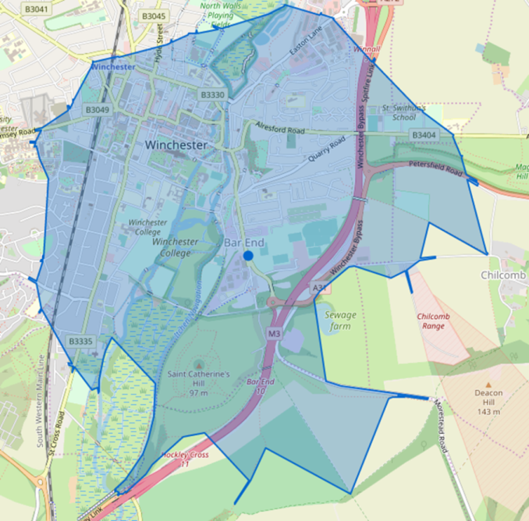 Figure 4 - Cycling Isochrone – 10 minutes

1. Family is regarded as up to 4 people with a maximum of 2 adults