Winchester District Health and Wellbeing Partnership Board - Action Plan 2016/18

‘Working Towards a Healthier Winchester’

Winchester City Council established the partnership in 2011 in preparation for the health reforms set out in the Health and Social Care Act 2012 and the need to develop a local forum where important crosscutting agendas could be addressed. The primary focus of the action plan is on addressing problems and issues which no one partner can tackle alone. It is organised around four main areas of work which reflect the priorities set out in the Hampshire Joint Health and Wellbeing Strategy 2013 – 2018:

- Starting and Developing Well: pregnancy, birth, early years and children and young people aged between 5 – 18 years (up to 24 years with additional needs).

- Living and Working Well: adults from 18 years and people of working age.

- Ageing Well: people aged 55 years and over.

- Healthier Communities: developing strong, supportive and resilient communities.

A fifth strand has been added to acknowledge the importance of identifying efficiencies and new ways of working and also to improve communications between organisations and with the residents of the Winchester District:

5 Efficient Delivery and Effective Communications

Proposed actions have been informed by the Joint Strategic Needs Assessment (JSNA) data, current evidence and local intelligence, including outputs from the ‘Spotlight on Mental Health’ event in June 2015. Wherever possible, the plan has also been aligned to the priorities of West Hampshire Clinical Commissioning Group and the local Mid Hants GP Federation, the Winchester District Community Strategy, Winchester City Council Portfolio Plans, and other relevant partnership action plans e.g. Winchester Walking Strategy, Winchester Homelessness Strategy, and Winchester District Cycling Strategy. It is a ‘living’ document that will continue to evolve in light of new evidence and updates to key strategic level plans.
Demography – Winchester District
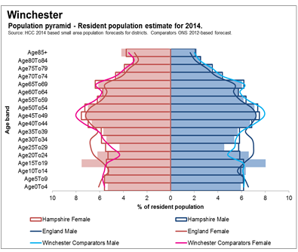
KEY ISSUES:

- A larger proportion of young people aged 15-19 years and 20-24 years
- By 2021signifiicant growth in all age groups, but in particular 0-19years (13.7%) and 20-39 years. In terms of impact of services largest percentage increase is in the over 85 year olds.

Chart 1: Population pyramid for Winchester
2014
2021
Difference
% Change
% Change
% Change
Age 0 T19
29902
34007
4105
13.7%
4.7%
4.6%
Age 20 To 39
26121
29754
3633
13.9%
2.0%
2.5%
Age 45 To 59
24280
25966
1686
6.9%
2.3%
2.5%
Age 60 To 74
19258
21088
1830
9.5%
10.3%
10.2%
Age 85+
3834
5077
1243
32.4%
32.6%
26.5%
Total
119086
133687
14601
12.3%
5.6%
5.0%
Population Change 2014 to 2021
Age band
Winchester
Winchester
Comparators
Hampshire

Starting and Developing Well

Aim: investing in the health and wellbeing of children and young people so they are able to enjoy life and achieve their full potential

Key issues

  - Working with families on minimising excess weight gain in children and young people in order to achieve a healthy weight
  - Develop and target interventions to support the emotional resilience, mental health and wellbeing of children and young people

Population: 25% of the population of the Winchester District is under 19 years of age – around 29,902 children and young people. This is similar to the national figures, with 23.7% of England’s population being 0-19 years of age. The projected population change for young people living in the Winchester District is forecast to be three times as many as other Winchester comparator areas (Table1).

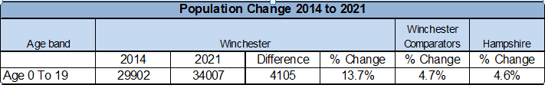
Table 1: Projected population change

Children in Poverty
There are 7.6% of children living in poverty in the Winchester district, compared to 18.6% nationally and 11% in Hampshire. Benchmarking against the CIPFA nearest neighbours shows that Winchester is doing better than the comparators, with East Hampshire having 8.4%, and Test Valley 9.5%. However, there is some variation across the district, with some areas having significantly higher proportions of children living in poverty, such as the wards of St Luke (22.1%) and St John and All Saints (18.7%) and more rural areas such as Droxford, Soberton and Hambledon (13.6%).

Smoking in Pregnancy: Latest data (2014/15) indicates that 9.7% of mothers in the Winchester District are smoking at the time of delivery, compared to 11.4% nationally and 10.3% in Hampshire. Smoking at the time of delivery has declined in Winchester over the past couple of years and this is in line with regional and national trends.

Breastfeeding: The evidence is well established, for both the benefits to mother and baby of breastfeeding, and the significant risks of not breastfeeding. Babies who breastfeed at a lower risk of gastroenteritis, respiratory infections, sudden infant death syndrome (SIDS), obesity, type 1 & 2 diabetes, and allergies (e.g. asthma, lactose intolerance). We know that rates tend to fall with increasing levels of social disadvantage, again putting a disadvantage upon those children growing up in poverty. For 2014/15, initiation rates in Winchester were good at around 83.1%, compared to 73.9% nationally, but continuation rates are not as encouraging. The breast feeding rate drops to around 64.9% by 6/8 weeks after birth.

Healthy weights: Research shows that children who stay a healthy weight tend to be fitter, healthier, better able to learn, and more self-confident. They are also much less likely to have health problems in later life. Overweight and obese children are also more likely to become obese adults, and have a higher risk of morbidity, disability and premature mortality in adulthood. The main obesity-related conditions that can develop during childhood and adolescence include asthma, type 2 diabetes, musculoskeletal problems, mental health disorders and cardiovascular risk factors. The uptake of the National Child Measurement Programme (NCMP) is very good in the Winchester District. Recent NCMP data indicates that 19.3% of 4-5 year olds (Chart 1) are overweight, compared to 22.5% nationally. However, by the time children reach 10-11 years old, the percentage increases to 26.4% being overweight (Chart 2). Whilst the Winchester district continues to be lower than national figures, this is in area that has not seen a drastic improvement over the past few years and the trend appears to be increasing.

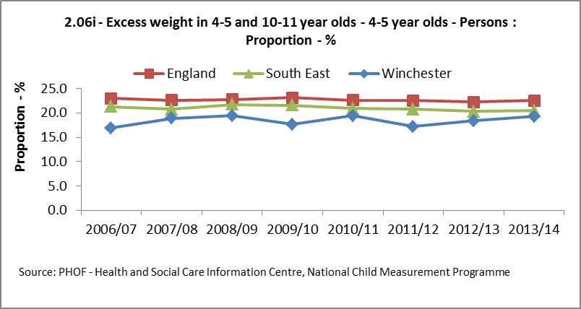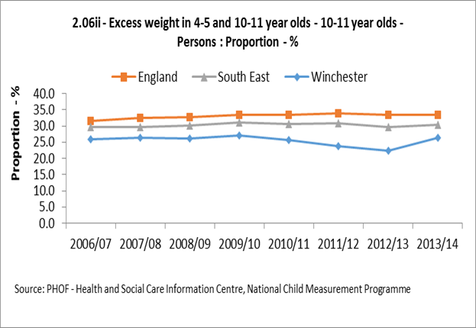

Chart 1: Excess Weight in 4-5 year olds in Winchester Chart 2: Excess weight in 10-11 year olds in Winchester

- Injury in infants & children: The evidence suggests association between childhood unintentional injuries and risk factors such as deprivation, maternal age and maternal mental wellbeing. Whilst the rate for Winchester (106.6 per 10,000) has decreased since 2013/14 and is now slightly below the England average (109.6 per 10,000), the rate for Winchester is higher when compared to South East comparators (103.6 per 10,000) (Chart 3). The rate for hospital admissions for unintentional and deliberate injuries for 15-24 year olds is increasing.

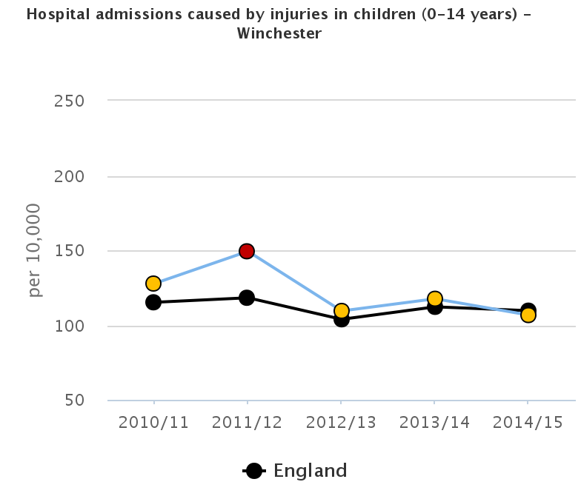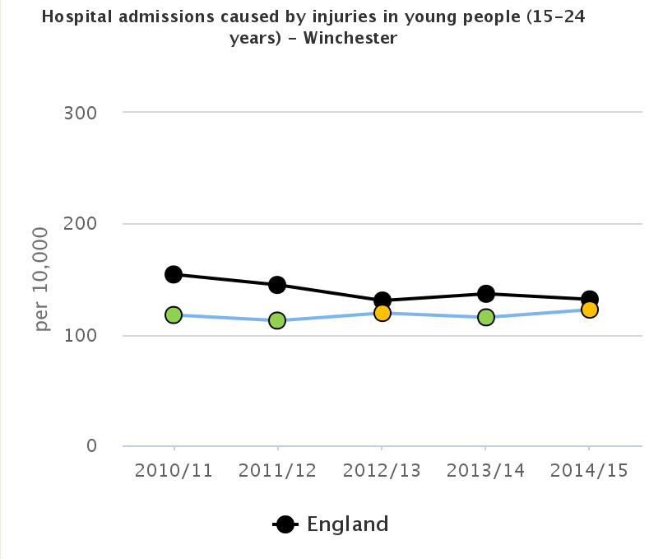
Chart 4 : Hospital admissions caused by unintentional and deliberate injuries in children (aged 15-24 years)

Chart 3 : Hospital admissions caused by unintentional and deliberate injuries in children (aged 0-14 years)

Education:
Educational qualifications are a key determinant of future employment and income, and educational attainment (or lack of it) is a key risk factor in teenage pregnancy, offending behaviour, truancy, and alcohol and drug misuse. There are also clear links between attainment, absenteeism and both current and future health outcomes for children and young people. Achievement in Early Years is a good predictor of achievement later in childhood.

A good level of development (age 5) is closely related to future educational attainment and there are significant gaps by social background. In Winchester, the proportion of pupils eligible for free school meals (FSM) achieving a “good level of development” in the Early Years Foundation Stage in 2014 is 45%. The equivalent figure for pupils not eligible for free school meals and unclassified pupils is 75%, meaning there is a gap in attainment of 30 percentage points.

In school, disadvantaged children are also showing an attainment gap. At the end of key stage 4, 46.8% of disadvantaged pupils (who either received Free School Meals, are Looked After Children or adopted from care) achieved 5+ A*-C including English and Maths GCSE, compared to 76.7% of pupils who were not disadvantaged.

Teenage conceptions: Teenage parenthood is closely associated with lone parenthood and girls in social class V households are 10 times more likely to become teenage mothers than those in social class I households. Teenage conceptions in Winchester (and England) have been steadily declining since 2007 (Chart X). Winchester has the second lowest under-18 conception rate in Hampshire.

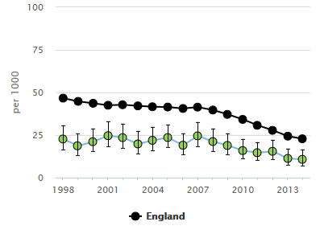
Chart X : Under 18 conceptions for Winchester District

Living and Working Well

Aim: Promoting healthier behaviours and encouraging people to take more responsibility for their own health and wellbeing

Key Issues

- Reducing healthy life expectancy; focus on improving lifestyles and self-management of health conditions, particularly diabetes
- Plateauing levels of Cancer mortality; improving prevention, early diagnosis and screening uptake
- Understanding impact of health conditions on disability (mental health, cancer, neurological conditions)

There are a wide number of factors that influence and determine good health, but there is no single definitive measure to tell us if we, or our communities, are healthy. Factors or conditions that cause premature mortality or illness can help us understand how healthy our population is. For adults the main causes of premature death are cancer, heart disease and respiratory disease, some of which are preventable (Chart X). Whilst the rate for Winchester was on the decline, the trend appears to be plateauing.

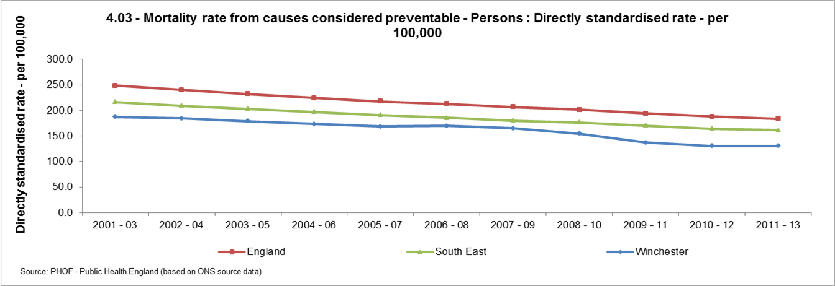
Chart X: Mortality rate from causes considered preventable.

Certain illnesses not only cause mortality but can also cause significant disability if they are not managed effectively and can also be indicators of poorer health both now and in the future. For example Diabetes and Mental Health.

Cancer: Cancer is the main cause of premature death. Rates of deaths from cancer in people under 75 years old have remained relatively flat for males but have decreased for females over the last few years, although a slight increase can be seen in most recent data for both. However this hides inequalities that exist in mortality rates between those living in the most and least deprived areas.
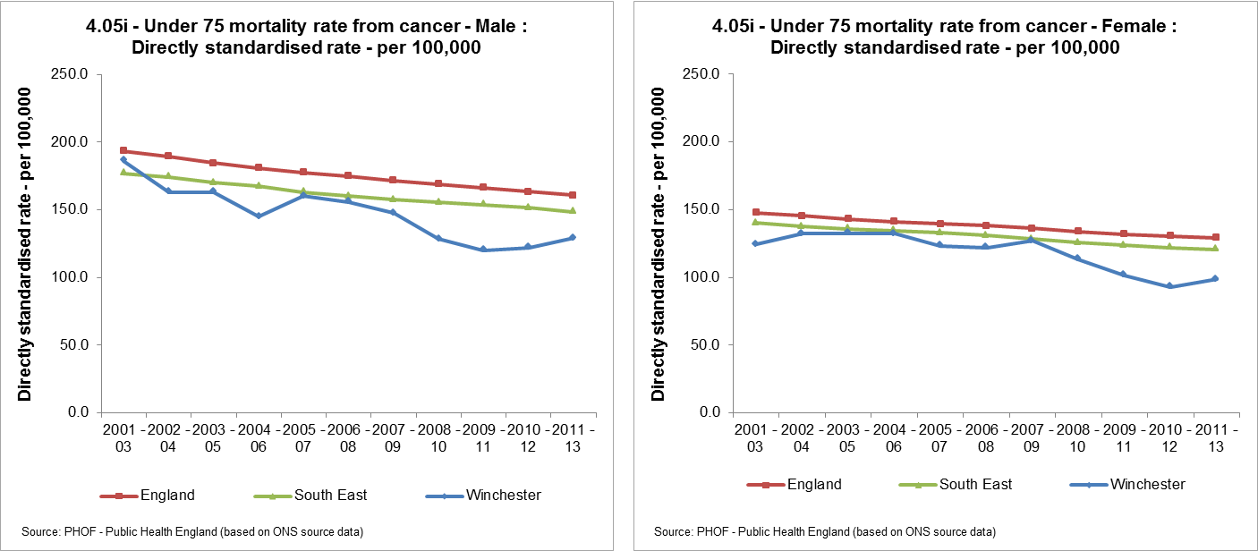

Melanoma is readily preventable with sensible precautions and, if found early, treatment can reduce the potential loss of many years of life. While the numbers are relatively small compared to other cancers, the latest figures show Hampshire to have a significantly higher than national or regional incidence of malignant melanoma. The variation across Hampshire shows generally higher levels in the southern Districts (including Winchester) compared to the more northerly ones.

Lifestyle Factors:

Alcohol: Alcohol contributes to a broad range of physical and mental health problems.

Estimates indicate that 24.6% of people over 16 in Winchester were increasing or high risk drinkers, compared to 22% in Havant and 22.3% in England. Winchester district has the highest estimate across the South East region.

While alcohol related admissions to hospital appear to be decreasing, alcohol related mortality is increasing for the Winchester district.
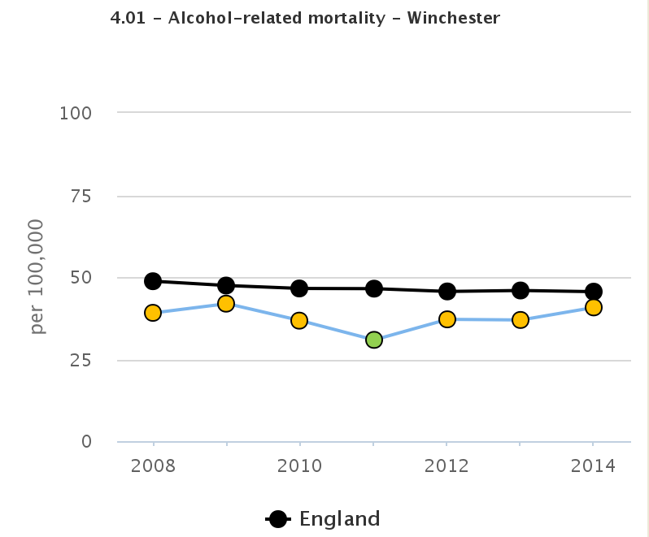
Alcohol-related mortality in the Winchester District

Smoking: Smoking is the most important cause of preventable ill health and premature mortality in the UK. It is estimated that 8.2% of people in the Winchester district smoke (Chart X). The smoking prevalence in Winchester is lower than both the national prevalence (18%) and the prevalence in CIPFA nearest neighbours - Test Valley (10%), East Hampshire (18.5%). However the percentage of ex-smokers in Winchester is 37% which is higher than when compared to England (33.9%)

Chart: Smoking prevalence in adults

Healthy Weights: Being overweight or obese can increase the risk of a number of serious and potentially life-threatening health conditions. It is estimated that 17.2 % of adults in the Winchester District are obese, 58.8% are overweight or obese. This is compared to figures of 23.3% of Hampshire adults who are obese and 65.8% overweight or obese. The percentage of adults that achieved at least 150 minutes physical activity per week is 63.4%, compared to 56% nationally, which is positive but there is still room for improvement.

Ageing Well

Aim: The promotion of active and healthy ageing
Key Issues:

- Focus on falls prevention; return on Investment for evidence-based exercise classes, improving independence
- Focus on preventable disabilities
- Focus on impact of loneliness and social isolation; partnership working on initiatives to reduce impact

Demographics: Demographic change is one of the biggest challenges facing the Winchester District. By 2021 it is estimated that 25% of the population will be 75+
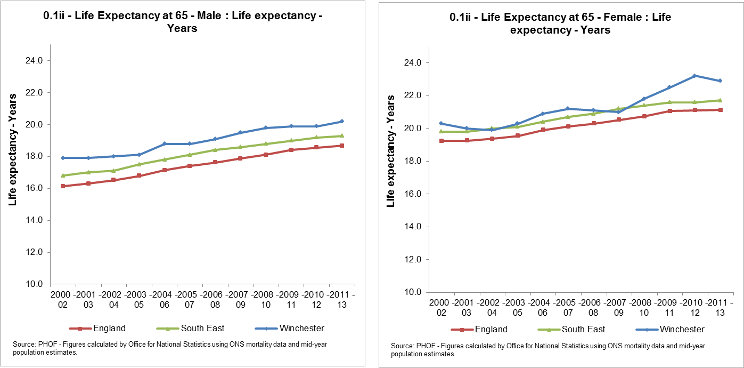

Older people in Hampshire generally remain fit and healthy for the majority of their remaining years. However, there have been some changes in recent years, whereby life expectancy has increased (Chart X) but the length of time people remain in good health has decreased. Understanding the impact of any changes in healthy life expectancy and life expectancy over time is important for the strategic planning of health and care services to ensure that resources are targeted effectively; as part of this it is important to develop prevention initiatives to improve healthy life expectancy, independence and a good quality of life.

Dementia: Dementia remains a key priority for the Winchester District. Dementia is a degenerative disease and therefore the needs of an individual for health and social care will change over time with the greatest need towards the end of life. There is growing evidence that certain dementias may be preventable, particularly vascular dementia. Primary focus needs to be on preventing people developing dementia where possible through supporting healthy lifestyles and reducing vascular disease. However, once diagnosed, the focus needs to be on supporting people to have the best quality of life that they can and remain independent and active for as long as possible. In the final phase of the condition the focus needs to be on ensuring good end of life care.

Loneliness & Isolation: Loneliness and Social Isolation have different meanings but are often used interchangeably; both can affect all ages but they do disproportionately affect older people. A systematic review found that people with stronger social relationships had a 50% increased likelihood of survival than those with weaker social relationships. The influence of social relationships on the risk of death is comparable with risk factors for mortality such as smoking and alcohol consumption and exceeds the influence of physical activity and obesity. Studies have shown that being lonely has a significant and lasting effect on blood pressure, with lonely individuals having higher blood pressure than their less lonely peers. A recent UK cohort study found that social isolation in older people was associated with increased risk of death from any cause. People with a high degree of loneliness are twice as likely to develop Alzheimer’s as people with a low degree of loneliness. These negative impacts on health lead to higher health and social care service use, while lonely and socially isolated older people are more likely to have early admission to residential or nursing care. While evidence demonstrates that isolation at any age can cause poor health, the scale of the problem is unknown. Therefore it is important that we become better at identifying people at risk of loneliness and isolation so that effective services can be targeted. Evidence on efforts to reduce social isolation has demonstrated positive outcomes for wellbeing, reduce mortality and morbidity, reduced utilisation of services and good return on investment. An in-depth review of the issues and evidence would be of benefit in the development of cost-effective and targeted initiatives to reduce the impact of isolation and loneliness.
Age UK has analysed data from the English Longitudinal Study on Ageing and determined a range of factors that people tend to have when they say they are lonely. The data was then used to produce data tables that applied the risk factors and weighting to the 2011 Census and identified the risk of loneliness at neighbourhood level. From this, maps of the local risk for loneliness for people aged 65+ have been created at district authority level. Several areas in the Winchester District indicate a very high risk of loneliness including parts of the City centre, Weeke, Winnall, Highcliffe, Bishops Waltham, Denmead and Wickham. The interactive map for the district can be found on http://www.ageuk.org.uk/professional-resources-home/research/loneliness-maps/

Falls: Falls are one of the main causes of loss of independence in older people. They are the largest cause of emergency hospital admissions in older people, and significantly impact on long term outcomes; for example, they are a major precipitant of people moving from their own home to long-term nursing or residential care. About one in three people over 65 years and half of people over 80 years fall at least once a year. A hip fracture is the most immediate consequence of falls among older people (Chart X).
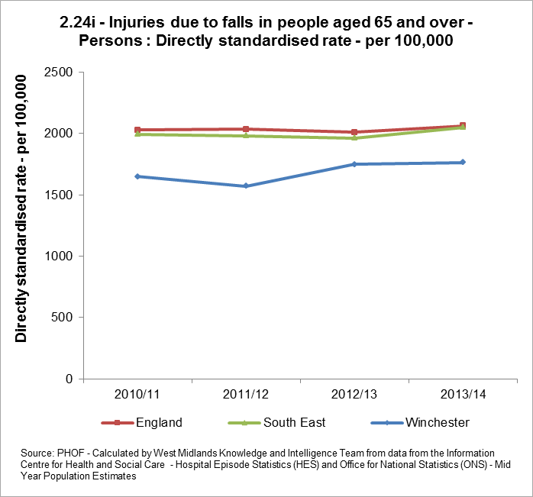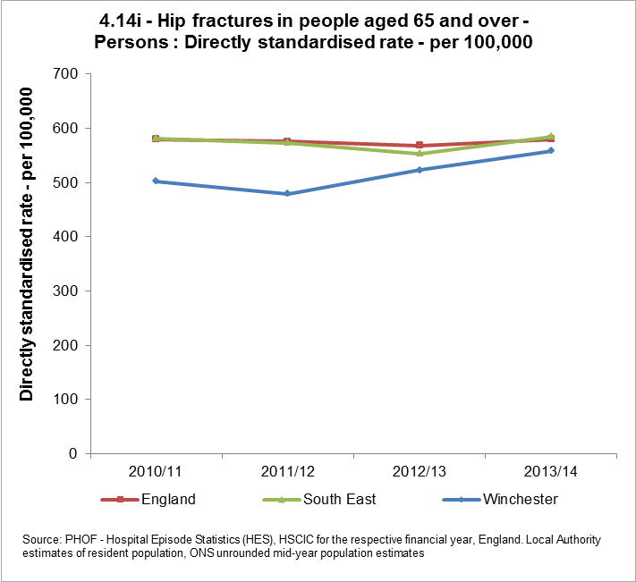

The consequences of hip fractures are significant – 10% of people sustaining a fracture will die within a month, 25% will die within 12 months, 30% will need long term care and 70% will suffer permanent new dependency in 2 or more Activities of Daily Living. 1 in 3 people over 65 and 1 in 2 people over 80 fall yearly. 40% of ambulance calls to people over 65 are due to falls.

Falling impacts on quality of life, health and healthcare costs. The biggest impact is on mobility. The ability to keep active and remain independent depends greatly on mobility. Mobility can be seriously limited as a consequence of age, by the effects of falls and subsequent physical inactivity. Half of those with hip fracture never regain their former level of mobility and 1 in 5 dies within 3 months.

Healthier Communities
Deprivation & health inequalities:

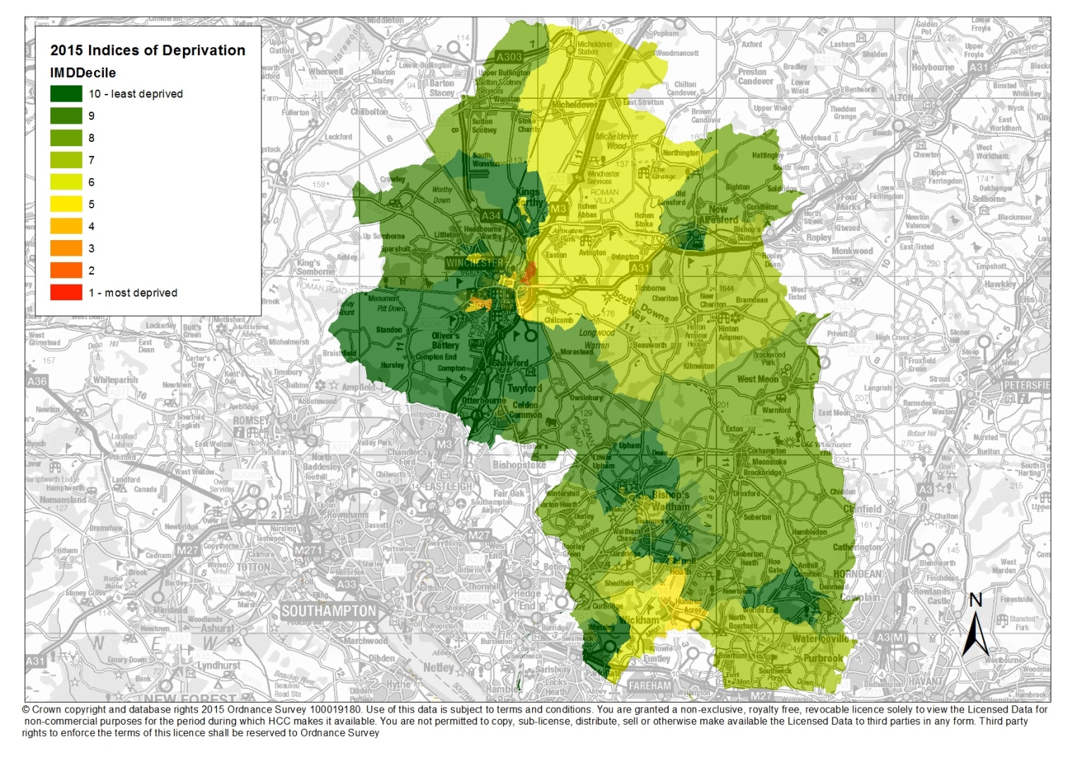

The Winchester District is generally considered to be affluent but health inequalities exist in certain wards primarily St John & All Saints (Winnall & Highcliffe), St Luke (Stanmore) and St Barnabas (Weeke)

Issues of child and adult obesity, smoking prevalence and teenage conceptions are generally worse in areas of identified deprivation. The majority of residents experiencing health inequalities are social housing tenants or from marginalised communities e.g. gypsies and travellers, Nepalese.

Access to services: there are pockets of rural deprivation in the district with potential access problems to health, social care and other services.

Vulnerable & disadvantaged families: - Although Winchester is perceived as a relatively affluent area it does have pockets of deprivation and vulnerable families in need of support. WCC manages local delivery of the Winchester Supporting Families Programme which is part of a Government initiative to support families with multiple, complex and persistent issues. A significant percentage of families which meet the criteria for this voluntary programme live in areas of identified deprivation and many are social housing tenants. Phase 2 of the programme began on 1 April 2015 for a period of 5 years, and involves working with a greater number of families with a broader range of problems, including health-related issues. The criteria for inclusion on the programme fall under six headings – families have to meet criteria under at least 2 of the headings in order to be considered for the programme. The six overarching headings are:-

1. Children who have not been attending school regularly
2. Parents and children involved in crime and anti-social behaviour
3. Children who need help e.g. identified via the Early Help Hub
4. Adults out of work or at risk of financial exclusion and young people at risk of worklessness
5. Families affected by domestic violence and abuse
6. Families with health problems

Addressing issues related to child and adult mental health is one of the major presenting issues for families on the Winchester Supporting Families programme and is also a growing concern within the wider community.

Mental Health:- following on from the ‘Throwing a Spotlight on Mental Health in the Winchester District’ event in June 2015, the board will prioritise issues related to mental health across the life course – from building resilience and promoting attachment in early years, to diagnosing and supporting conditions and encouraging the provision of appropriate treatment services. Children and adults falling just below the threshold for specialist services are of particular interest to the board.

Fuel Poverty: fuel poverty has severe effects on some of the most vulnerable people in society particularly older people and families with children. It is estimated that 3,601 households are living in fuel poverty in the Winchester District i.e. 7.5% compared to an average of 8.1% in the south east region. Fuel poverty is linked to excess Winter deaths.

Homelessness: - Vulnerable individuals and disadvantaged families are particularly at risk of homelessness, and are therefore of concern to the partnership. This might include older people, people with disabilities, rough sleepers and people with substance misuse or mental health issues. The partnership will work closely with the Winchester Homelessness Forum where priorities align.

http://fingertips.phe.org.uk/search/poverty#page/4/gid/1/pat/6/par/E12000008/ati/101/are/E07000094/iid/10101/age/169/sex/4
CIPFA (The Chartered Institute of Public Finance and Accountancy) developed the Nearest Neighbours Model to aid local authorities in comparative and benchmarking exercises. The factors upon which the classifications are based provide a balanced representation of the authorities' traits. The variables employed in making the assessment are all therefore descriptive of characteristics of the area each authority administers and not of the way in which resource of services are taken into account.
Source: http://www.unicef.org.uk/BabyFriendly/About-Baby-Friendly/Breastfeeding-in-the-UK/Health-benefits/
Professor Nick Spencer. Health Consequences of Poverty for Children. Published by End Child Poverty. http://www.endchildpoverty.org.uk/files/Health_consequences_of_Poverty_for_children.pdf
Source: http://www.nhs.uk/Livewell/childhealth6-15/Pages/child-health-measurement-programme-healthy-weight-advice.aspx
Source: http://www.noo.org.uk/NOO_about_obesity/obesity_and_health/health_risk_child
The NICE guidance uses the term 'unintentional injuries' rather than 'accidents' as: "most injuries and their precipitating events are predictable and preventable"[1]. The term 'accident' implies an unpredictable and therefore unavoidable event.
Professor Nick Spencer. Health Consequences of Poverty for Children. Published by End Child Poverty. http://www.endchildpoverty.org.uk/files/Health_consequences_of_Poverty_for_children.pdf

