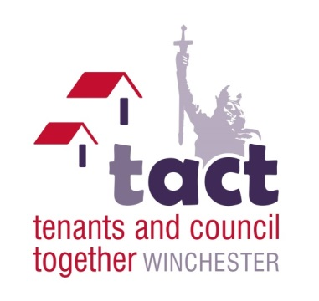
TACT Chairs Annual Report 2019
It has been another busy year for TACT as we follow up and support issues raised at TACT meetings.
At last year’s AGM a tenant from Hyde Gate Sheltered Housing Scheme highlighted a problem at Hyde Gate regarding a hostel for drug dependants which was impacting on tenant lives due to anti-social behaviour. As a result, TACT have arranged and attended 4 meetings between tenants, local resident officers, local Councillors, PSO’s and the hostel management to try and address some of the issues. TACT are aware that this is not a problem easily solved and will continue to arrange further meetings.
A resident from Simons Court, Abbotts Barton raised concerns at a TACT meeting about the deterioration of the area around Simons Court, Colbourne Court and the new builds at Hillier Way, which they had raised with the council over a 3 year period, but no action had been taken. As a result of them raising it at TACT, a walkabout was immediately arranged with 2 officers from WCC Housing Department, a local councillor, the TACT Chair and a tenant from Simons Court. Consequently, the officers took away a list of actions to raise as work jobs, to bring the area back up to standard again. TACT will continue to monitor the situation.
At the TACT social meeting in May, the WCC Sports team were given feedback regarding the desire to see the twice yearly half term football competition brought back, which was previously enjoyed by many children in the district who participated in the tournament. The Officer’s took this feedback on board, and as a result the event has been reintroduced with the first final match taking place on 1st November 2019.
TACT have also worked closely with the Scrutiny Group looking into Communications between the council and tenants. As a result of their findings, the group have submitted their final report containing 67 recommendations, to the Head of Housing (Interim) in October 2019. The report will be available online once it has been presented to Cabinet in early 2020.
Additionally, TACT has also supported the two Service Delivery Groups which have been working towards improvements in Housing Management and Repairs and Maintenance.
Following the Grenfell Tower Fire, the Hackett Report (which looked into the causes of the fire), is due for release to councils before the end of the year and will contain recommendations. WCC have already pre-empted the report by setting up a Fire Strategy Project which consists of several groups, each with a member of TACT Support looking at different aspects of Fire Safety and other safety issues in and outside the home.
Following the local elections in May, we saw a change in administration at the council which is now led by the Liberal Party. This has meant some changes in how they conduct their business, and there is no longer a Housing Cabinet meeting. This has been replaced by the Business and Housing Committee which his attended by the TACT Chair and Communications Officer. Their presence ensures that the views of TACT are taken into consideration. The Chair also attends all Cabinet meetings and is asked to comment on any issue relating to tenants and housing.
As Chair, it is always helpful to have the support of other TACT members when decisions have to be made, which cannot always come before a full TACT meeting. Therefore I would like to thank; Sue Down (Vice Chair), Michael Fawcitt (Communications Officer), Tony White, David Chafe, David Light, Chris Barton-Briddon, Mick Collins, June Glass and Joan Stevens (who regrettably had to retire recently due to health reasons). Their support is invaluable. Additionally, I would like to thank Michelle Smith (Tenant Involvement Officer) who diligently takes the TACT minutes, (not an easy task for anyone who has ever taken minutes at a meeting), and for her continued support to the Chair with general administration.
Additionally, thank you to everyone who attends the TACT meetings on a regular basis, and who contributes to the lively debate and feedback which ensues.
Our thanks also to Council Officers and Councillors who support us throughout the year which is much appreciated.
Prepared by Monica Gill
TACT Chair
October 2019

