The New Star Rating System and Reinspections

- The Animal Welfare (Licensing of Activities Involving Animals) (England) Regulations 2018 have introduced a new way of licensing for the following activities;

Boarding dogs at kennels
Boarding cats at catteries
Home boarding of dogs
Daycare for dogs
Dog breeding
Selling animals as pets
Keeping a riding establishment or the hiring out of horses
Keeping or training animals for exhibition

- Licences may now be issued for one, two or three years and the length of licence is determined by the star rating as shown in Table 1. [The exception is keeping or training animals for exhibition – these licences will not be star rated and, if granted, a licence will be for 3 years].

- The star rating is awarded based on the inspection of the premises and the risk rating.

- The inspection of the premises will determine whether the basic standards are met but with some minor failings, whether the basic standards are met without failings, or whether the basic and higher standards are met. For details of the standards, please see the regulations and the guidance documents. There are links to these on the website.

- The risk rating is shown in Table 2.

- If a premises feels that the star rating that has been awarded to them is incorrect, they may appeal to the Council. The procedure for doing this is available on a separate document.

- If a licensed premises wishes to complete works that they believe will increase their star rating, they may apply for a reinspection at any time. However, they would have to pay the full licence fee and would have to submit in writing the reasons that they are requesting a reinspection and listing any work that has been completed since the licence was issued.

Table 1 Scoring Matrix for the Star Rating
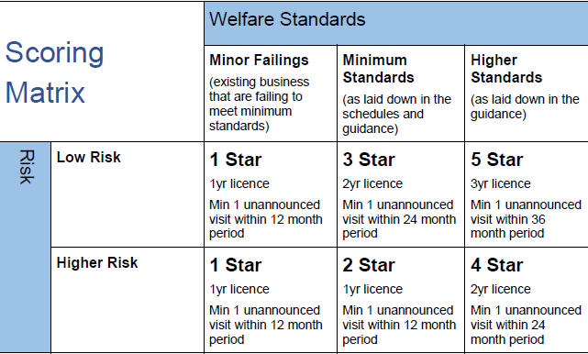

Table 2 Risk Rating Form
